Hochschule Rhein-Waal



and

Fluxana GmbH & Co. KG



**Robotic arm Automation – using ROS (Robot Operating System)**

29 June 2023

Internship Report

Abdelrahman Mostafa (29528)

Bachelor of Mechatronic Systems Engineering

Supervised by:

Dr. Rainer Schramm, Fluxana GmbH  
Prof. Dr. Ronny Hartanto, HSRW

Abstract

This internship report focuses on the implementation of the Niryo Ned2 robot in conjunction with the Fluxana library to address the need for efficient and precise powder dosage tasks. With the increasing demand for automated and accurate powder dosage operations, traditional manual methods are becoming insufficient. Collaborative robots, such as the Niryo Ned2, offer the potential to enhance efficiency and precision in these tasks.

The aim of this internship project is to seamlessly integrate the Niryo Ned2 robot with the Fluxana library and optimize its functionalities to achieve effective powder dosage. By leveraging the capabilities of ROS and Moveit frameworks, along with the Fluxana cobot library, a comprehensive solution is developed to tackle the challenges associated with powder dosage.

The methodology employed in this internship involves gaining in-depth knowledge of ROS and Moveit frameworks, expanding the Fluxana library to meet the specific requirements of the Niryo Ned2 robot, and executing and validating the powder dosage task. Through meticulous experimentation and analysis, the precision and reliability of the system are assessed.

The most important results obtained from this internship project demonstrate a significant improvement in precision compared to initial experiments. The errors in each axis were reduced to a maximum of approximately 0.7 mm in the Z-axis, 0.5 mm in the Y-axis, and less than 0.4 mm in the X-axis. The achieved level of accuracy, with a percentage improvement of 93%, proves to be acceptable for the desired powder dosage task.

Overall, this internship report contributes to the advancement of automation in powder dosage processes by seamlessly integrating the Niryo Ned2 robot with the Fluxana library. The integration of ROS and Moveit frameworks enhances efficiency, accuracy, and repeatability in powder dosage tasks. The results obtained highlight the potential for further improvements and emphasize the importance of leveraging robotics technology to address the challenges associated with manual powder dosage methods.

Acknowledgement

I would like to express my sincere gratitude to the following individuals for their invaluable contributions and support throughout the preparation of this internship report:

First, I would like to extend my deepest appreciation to **Prof. Dr. Ronny Hartanto**, my university supervisor at HSRW. His insightful feedback and constructive criticism greatly shaped the direction and content of this report, elevating its quality.

I would also like to express my heartfelt thanks to **Dr. Rainer Schramm**, CEO of Fluxana GmbH, for serving as my company supervisor during this internship. His extensive knowledge and industry experience have been invaluable in understanding the practical aspects of implementing the Niryo Ned2 robot and Fluxana library. His guidance and feedback have played a pivotal role in the successful completion of this project.

A special note of appreciation goes to **Carine Silva Allen**, Mechanical Engineer at Fluxana. Her dedication and commitment in supervising my learning path have been remarkable. Her expertise and insights have helped me navigate through various challenges and explore new avenues in robotics and automation.

Finally, I would also like to extend my thanks to the entire team at Fluxana GmbH for their support and cooperation throughout the internship period. The collaborative environment and rich learning opportunities provided by the company have contributed significantly to my professional growth.

Thank you all for your valuable input, guidance, and support. Your contributions have been instrumental in the successful completion of this internship report.

Table of Contents

1 Introduction 7

2 Related Works 9

3 Experiments 10

3.1 Methodology 10

3.2 Experiment 1 11

3.3 Experiment 2 13

4 summary of Internship Activities 15

5 Niryo Ned2 Specifications 16

6 Linux OS and Ubuntu 18

6.1 Directory Structure 18

6.2 Important Linux commands 19

7 Getting to Know ROS1 20

7.1 The Philosophical Objectives of ROS 21

A. Peer-to-Peer 21

B. Multi-lingual 21

C. Tool-oriented 22

D. Thin 22

E. Free and Open-Source 23

7.2 Moveit 24

8 1st Automation Python Program Using Moveit_commander & Tkinter 26

8.1 Dependences 27

8.2 Graphical User Interface through tkinter 28

8.3 Functions & Buttons 31

8.3.1 Motor Calibration 31

8.3.2 requiest a new calibration 31

8.3.3 Get Joints & Pose values 32

8.3.4 Moving Pose in each Axis 33

8.3.5 Plan a Pre-Saved Positions & Execute it 34

9 Building a GENERAL-PURPOSE FLUXANA Ros library 35

9.1 Most important functions 35

9.1.1 Subscribe to a ROS-Topic 35

9.1.2 Call a ROS-Service 36

9.1.3 Get Current position values 37

9.1.4 use forward kinematics solver from moveit 38

9.1.5 Moving the arm 39

10 Results and Discussion 40

1st experiment 40

Visualising the results from 2nd experiment: 40

11 CONCLUSIONS 42

References 43

Appendix 44

Appendix A: Initialization of GUI with tkinter, using python 2.7 45

Appendix B: Full code of the GUI used to PRESENT Niryo at hsrw event 48

Appendix C: FX_ROS LIBRARY 75

List of FIGURES

Figure 1: Niryo Ned 2 Robot 8

Figure 2: Experiment Visualisation. 10

Figure 3: Experiment 1st Position 10

Figure 4: Experiment 2nd Position 11

Figure 5: Code for 1st experiment 11

Figure 6: The errors result graph for the 1st experiment after 10 iterations. 12

Figure 7: How the current pose calculated in 1st experiment. 12

Figure 8: The errors result graph for the 1st experiment after 100 iterations. 13

Figure 9: Code for 2nd experiment 13

Figure 10: 3D View of the robot. 17

Figure 11: Linux System Directory Structure 18

Figure 12: Communication in ROS 20

Figure 13: The Planning Scene in MoveIt! 24

Figure 14: Move_group Node in MoveIt! 25

Figure 15: Initial Stage of the GUI 28

Figure 16: Second Stage of the GUI 28

Figure 17: Third Stage of the GUI 29

Figure 18: Final Stage in the GUI 30

Figure 20: The errors result graph for the 2nd experiment after 100 iterations. 40

Figure 19: The errors result graph for the 2nd experiment after 20 iterations. 40

List of Tables

Table 1: Description of the technical specifications of Ned2 16

Table 2: Important Linux Command lines 19

# Introduction

The field of robotics has witnessed remarkable progress in recent years, revolutionizing various industrial processes and offering solutions to complex tasks. One crucial area of focus involves the programming and automation of robotic arms, which play a pivotal role in executing precise and repetitive operations across multiple industries. This report presents the outcomes and discoveries from an internship project that aimed to program and automate the Niryo 2 robotic arm utilizing the ROS1 (Robot Operating System) framework.

The Niryo 2 robotic arm provides a flexible and cost-effective solution for automation tasks, thanks to its modular design and user-friendly control interfaces. This internship project focused on harnessing the capabilities of the ROS1 ecosystem, particularly the MoveIt motion planning framework, to enhance the motion planning and manipulation capabilities of the Niryo 2 arm. By leveraging the powerful tools and libraries offered by ROS1, the objective was to optimize trajectory generation, improve collision avoidance, and enable efficient object manipulation in diverse scenarios.

This report provides a comprehensive overview of the internship project, outlining the objectives, methodology, and significant findings. It offers insights into the research question, the experimental setup, and the implementation of advanced motion planning algorithms using the MoveIt package. Furthermore, it addresses the challenges encountered during the project and discusses the potential implications and future directions of the research.

The research conducted in this internship project contributes to the broader field of robotics and automation by exploring the application of ROS1 and MoveIt in programming and automating the Niryo 2 robotic arm. The findings and insights gained from this project serve as a foundation for further advancements in motion planning, manipulation, and human-robot interaction.

In summary, this report provides a comprehensive account of the internship project's progress, documenting the achieved milestones, lessons learned, and the potential impact of the research. It serves as a valuable resource for researchers, practitioners, and enthusiasts interested in programming and automating robotic arms using ROS1 and the Niryo 2 platform. The outcomes of this project pave the way for continued advancements in robotic arm automation, enhancing the efficiency and effectiveness of industrial processes.

**Research Question**: To what extent can the integration of the Niryo 2 robotic arm with the ROS1 framework, incorporating the MoveIt motion planning framework, optimize motion planning, manipulation, and automation for efficient execution of a powder dosage task?

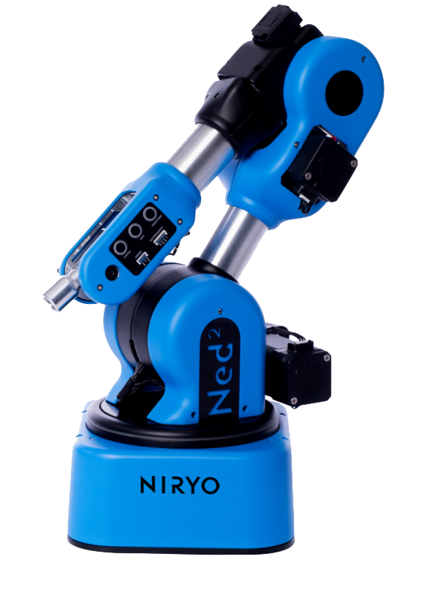

Figure : Niryo Ned 2 Robot

# 2 Related Works

This chapter of our research paper provides an extensive review of studies focusing on the integration of robotic arms with motion planning frameworks, particularly within the context of the ROS1 framework. We explore previous research that has examined the optimization of motion planning, manipulation, and automation capabilities in various applications.

One relevant study by (St-Onge & Herath, 2022) investigated the integration of a robotic arm with ROS1 and the MoveIt framework for precise object manipulation tasks in manufacturing. Their work emphasized the use of advanced motion planning algorithms and collision avoidance techniques to improve the efficiency and accuracy of the robotic arm's movements.

Additionally, the research conducted by Chand (2022) focused on the development of a novel MATLAB controller for the Niryo Ned Robot. The Ned robot, an open-source technology robotic arm designed for education, research, and vocational training, provides Niryo Studio as a configuration and basic program implementation tool. However, the current control capabilities of the Ned robot through MATLAB are limited. Chand addressed this limitation by developing a MATLAB controller, which offers the advantage of leveraging various toolboxes for machine learning, control, and image processing, making it suitable for research and development purposes.

Chand's research paper presented the implementation and evaluation of the developed MATLAB controller on a real Niryo Ned Robot. Four target coordinate locations representing the edges of the robot's workspace were utilized for evaluation. The results demonstrated the functionality and effectiveness of the MATLAB controller in controlling the Niryo Ned Robot. This study aligns with our research paper as it also explores the control aspects of the Niryo Ned Robot. However, while Chand's work primarily focused on the development of the MATLAB controller, our research aims to extend the capabilities of the Niryo Ned2 robot by integrating it with the ROS1 framework and MoveIt using Python user interface to control. By integrating the insights gained from Chand's study and our own research, we can further enhance the control and automation functionalities of the Niryo Ned2 robot, specifically for powder dosage tasks.

While these studies have made significant contributions to the field, they primarily focused on specific applications or aspects of robotic arm integration. In our research, we aim to build upon their findings by specifically addressing the optimization of motion planning, manipulation, and automation for a powder dosage task using the Niryo 2 robotic arm. By examining the gaps and limitations identified in previous studies, we intend to extend the existing knowledge and contribute to the advancement of efficient powder dosage tasks in a manufacturing setting.

# 3 Experiments

This section presents the experimental setup conducted to assess the accuracy of the Niryo robot. The objective of these experiments is to ensure that the robot's precision is dependable for performing power dosage tasks that require a high level of accuracy.

## 3.1 Methodology

To evaluate the robot's accuracy, a methodology was devised wherein an existing software was automated to repetitively move the robot to predefined coordinates. The true coordinates were then obtained from the joint sensors, and the absolute error in all three axes (x, y, z) was analysed. These experiments were conducted to quantitatively measure the level of precision achieved by the robot and validate its performance in real-world scenarios. The process was moving from Forward position to the pen-pointing position.

Equipments needed:

* Niryo Ned 2 robotic arm
* Python automated software
* Pen
* White paper
* Custom gripper designed by Fluxana

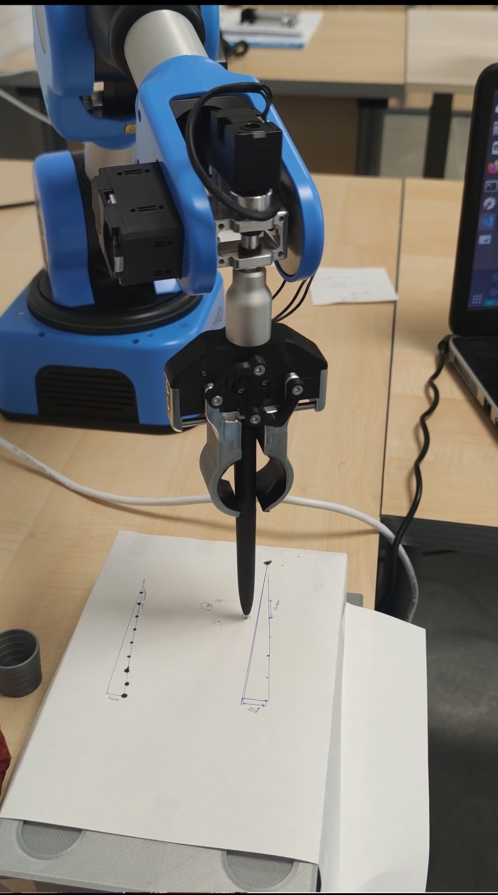

Figure : Experiment Visualisation.

The inclusion of pen and paper, as depicted in *Figure 2*, serves a visual purpose during the execution of the automated process. Its presence enables us to visually assess the representativeness of the results displayed in the graphs and identify any potential anomalies or discrepancies that may have occurred during the experiment. By having a physical reference alongside the generated data, we can ensure the reliability and accuracy of the experimental outcomes.

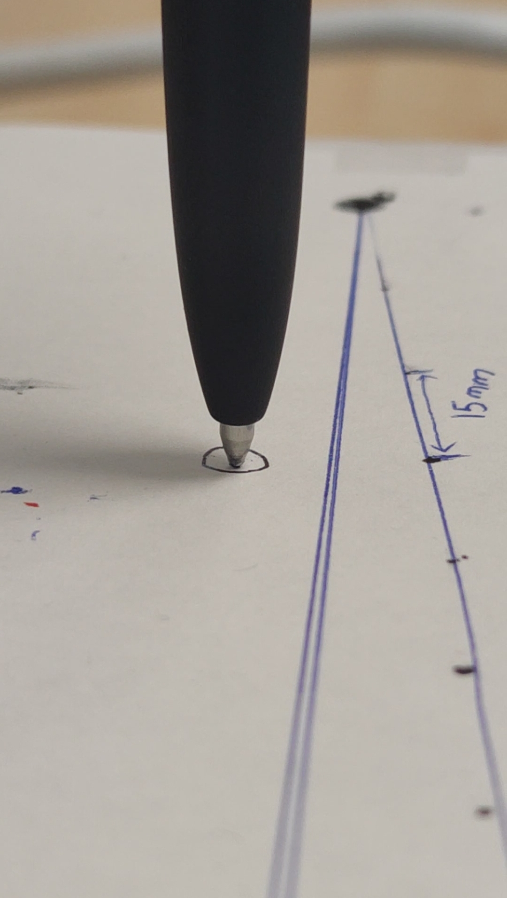

Figure : Experiment 1st Position

## 3.2 Experiment 1

This experiment involved a slight deviation from the two previously mentioned positions. The objective was to repetitively move the robot to a desired coordinate with an acceptable margin of error. Initially, visual observation was employed to assess whether the robot consistently reached the same position, but it became apparent that the robot's position varied each time. To address this, a code was developed to quantify the error in each axis as shown in *Figure 5*, making it possible to measure and evaluate the level of deviation experienced by the robot during its movements. This approach aimed to provide a more objective and measurable analysis of the robot's performance in achieving precise positioning.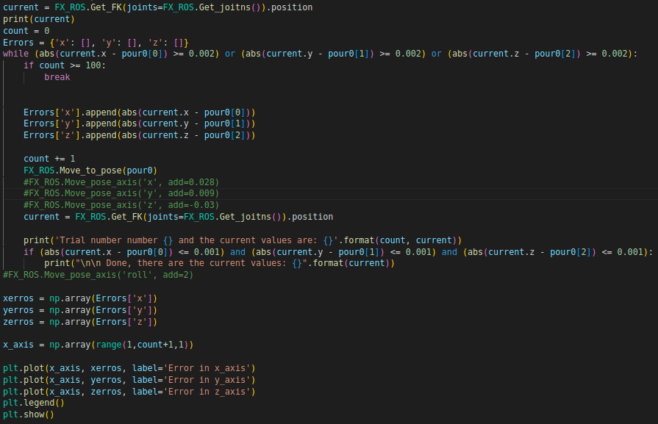

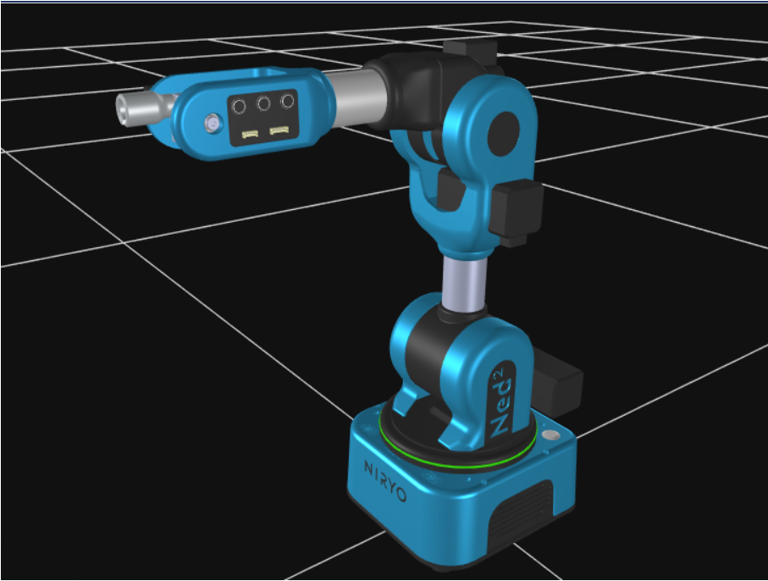

Figure : Experiment 2nd Position

Figure : Code for 1st experiment

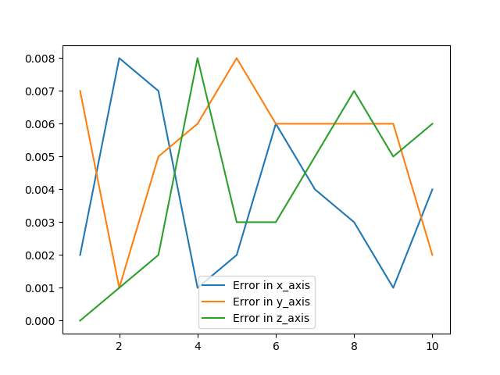

Figure : The errors result graph for the 1st experiment after 10 iterations.

*Figure 6* displays a plot that encompasses the following characteristics:

* It visualizes the errors observed in the x, y, and z axes, allowing for a comprehensive assessment of precision.
* The x-axis of the graph corresponds to the trial number, indicating the sequence of experiments conducted.
* Meanwhile, the y-axis represents the error measured in meters (m), providing a quantitative measure of the deviations observed in each trial.

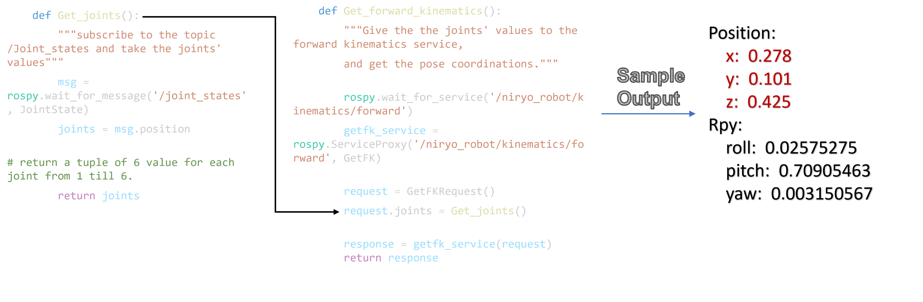

Figure : How the current pose calculated in 1st experiment.

*Figure 8* displays a plot that encompasses the following characteristics:

* It visualizes the errors observed in the x, y, and z axes, allowing for a comprehensive assessment of precision.
* The x-axis of the graph corresponds to the trial number, indicating the sequence of experiments conducted.
* Meanwhile, the y-axis represents the error measured in meters (m), providing a quantitative measure of the deviations observed in each trial.

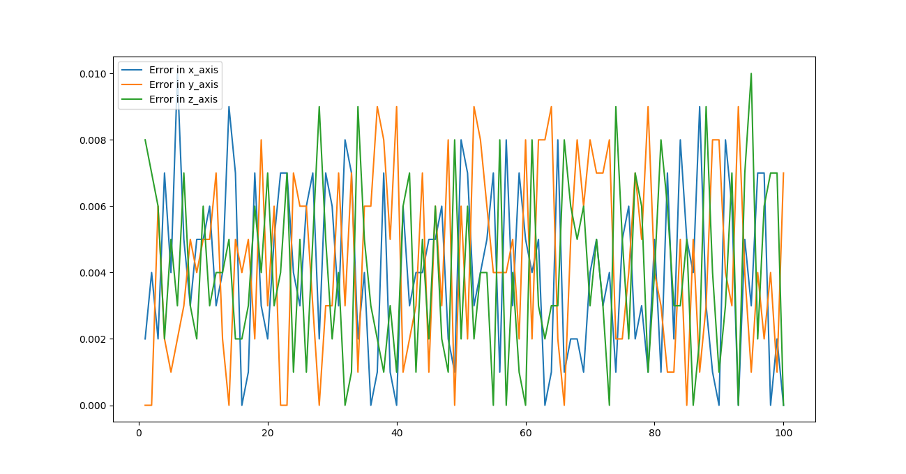

Figure : The errors result graph for the 1st experiment after 100 iterations.

## 3.3 Experiment 2

In this experiment, I used the approach mentioned in the beginning of the chapter, where we have two positions 1, and 2 as shown in *Figure 3 & 4*.

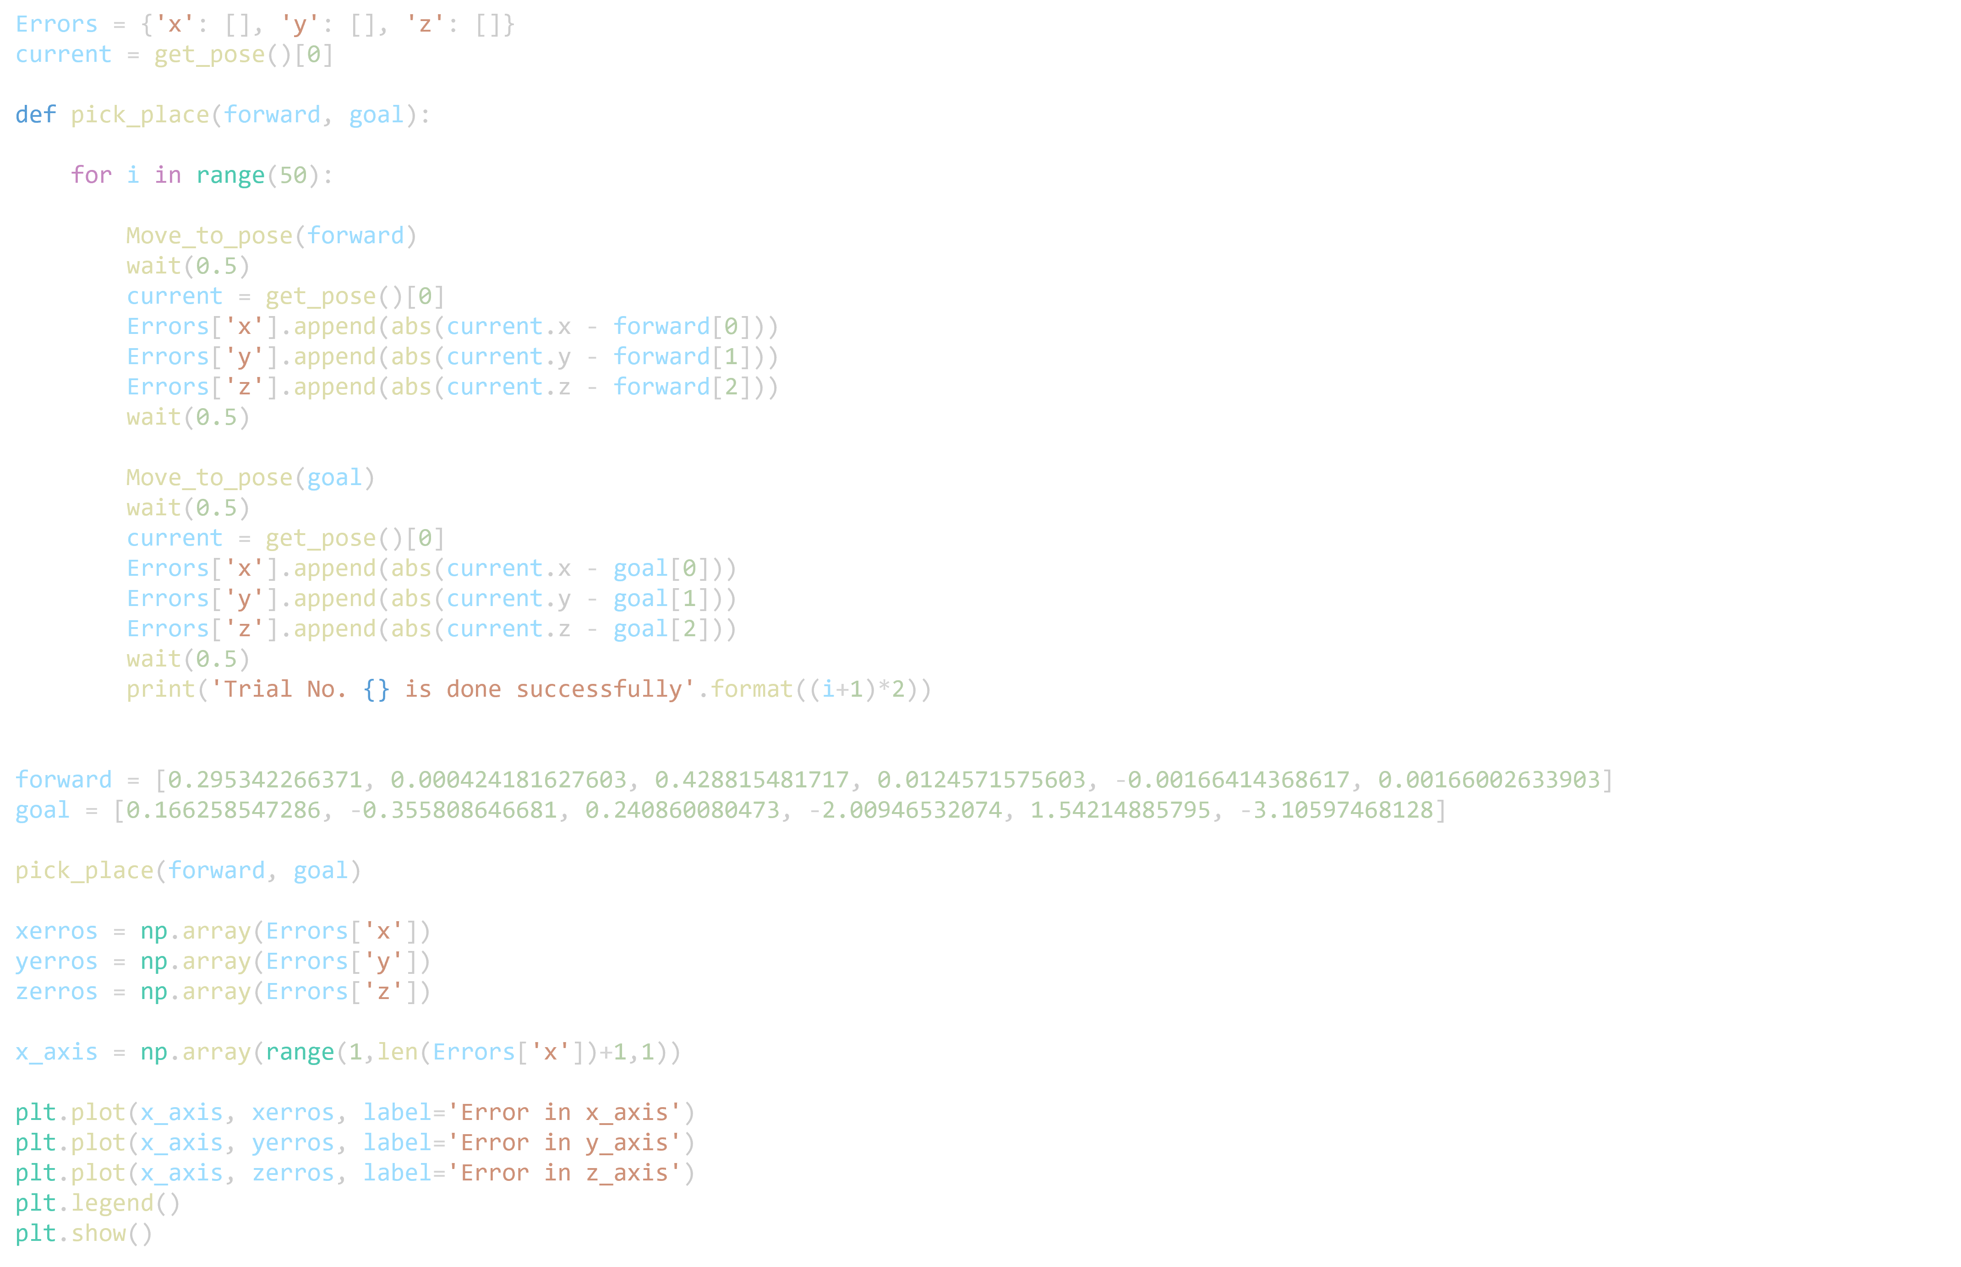

Figure : Code for 2nd experiment

Changes made to increase accuracy:

* 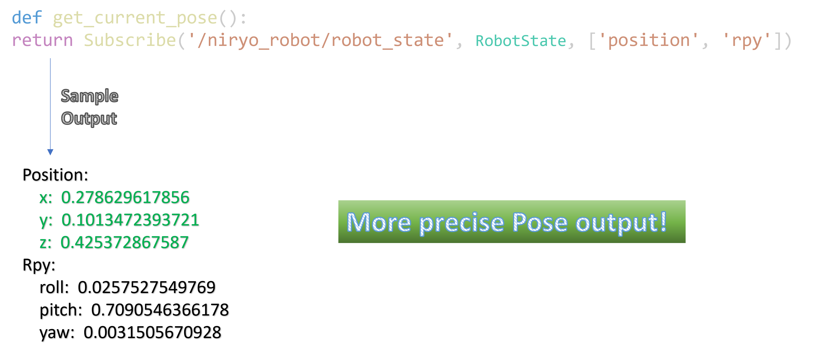Get the current Pose values from the **RobotState** topic directly
* 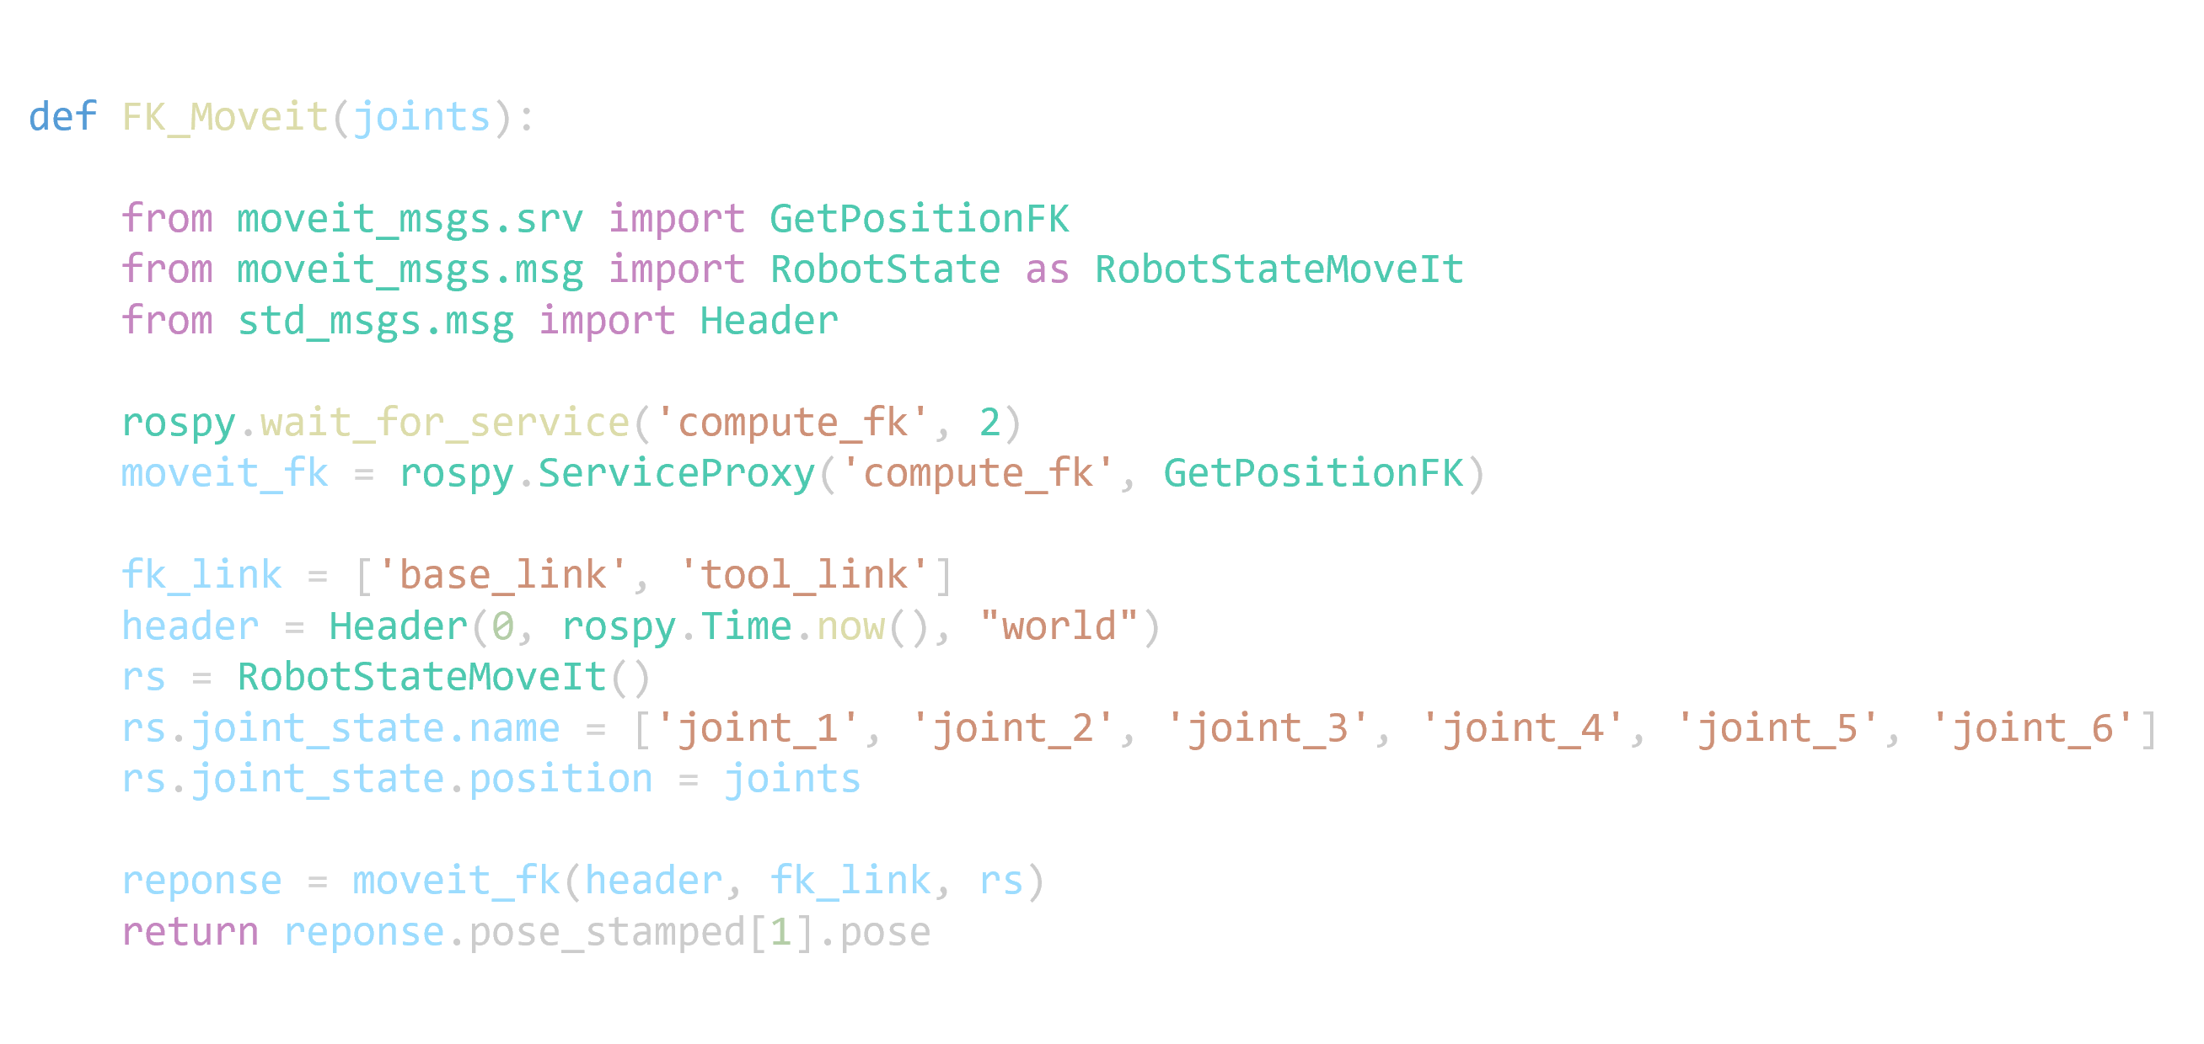Use **Forward kinematics service from MoveIt** rather than the one provided from Niryo
* 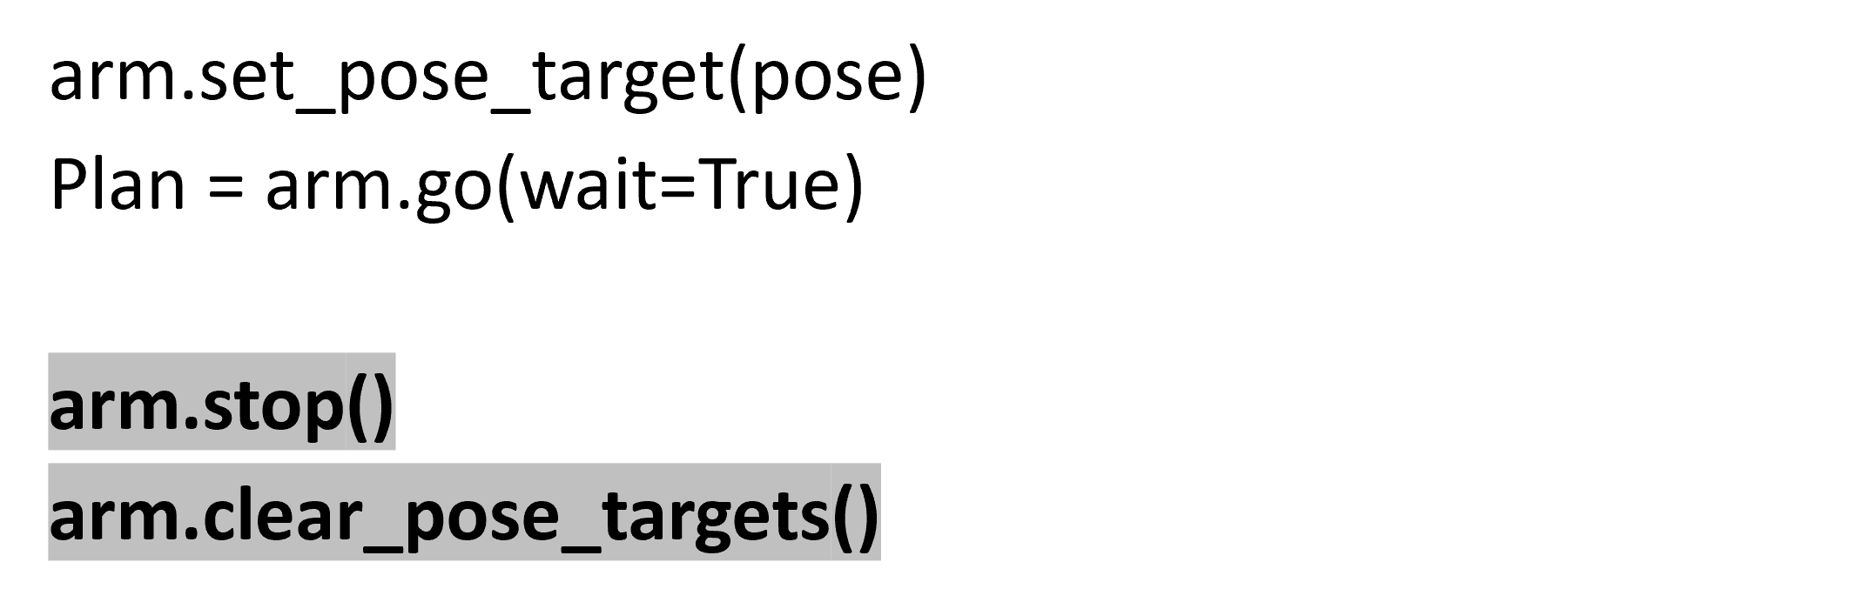**Clear the Pose targets** after each motion planning using Pose.

Following significant improvements implemented, the results of the second experiment are presented and analysed in the dedicated *Results and Discussion* chapter. The enhancements made have had a substantial impact on the outcomes, warranting a thorough examination and discussion of the obtained results.

# 4 summary of Internship Activities

In this chapter, we present a comprehensive Summary and overview of the key activities undertaken during the internship program focused on programming and automating the Niryo 2 robotic arm using the ROS1 framework. The chapter highlights the learning process, and milestones achieved throughout the internship, covering a range of essential topics.

The chapter begins with Activity 1: Getting familiar with Linux and Ubuntu. This activity focuses on familiarizing oneself with the Linux operating system and Ubuntu distribution, which serve as the foundation for ROS1 development. It includes exploring the command-line interface, file system navigation, package management, and basic shell scripting. A solid understanding of Linux and Ubuntu is crucial for effectively working with ROS1.

Activity 2: Getting to Know ROS1 forms the next phase of the internship. This activity delves into the fundamental concepts of ROS1, including its architecture, communication mechanisms, and core components. It explores topics such as nodes, topics, services, and actions, which are the building blocks of ROS1-based applications. A deep understanding of ROS1 is vital for leveraging its capabilities and developing robust and efficient robotic systems.

Activity 3: Building an Automation Program using the Moveit framework and tkinter for the GUI represents a significant milestone in the internship. This activity focuses on integrating the Moveit framework, a powerful motion planning library, with a graphical user interface (GUI) developed using the tkinter library. The goal is to create an intuitive and user-friendly interface for controlling the Niryo 2 robotic arm. The activity involves designing and implementing motion planning algorithms, handling user inputs, visualizing the robot's state, and executing motion trajectories.

Activity 4: Making a General-Purpose Python Library with Moveit aims to extend the capabilities of the Moveit framework by developing a reusable and optimized Python library. This library provides a set of high-level functions and utilities that simplify common tasks in robotic motion planning and automation. The activity involves designing the library's API, implementing key functionalities, and optimizing the codebase for improved performance and usability. The resulting library can be utilized in various robotics projects, enhancing productivity, and promoting code reusability.

Throughout the following chapters, each activity is discussed in detail, encompassing the objectives, methodologies, challenges faced, and the corresponding outcomes. Practical examples, code snippets, and graphical representations are provided to illustrate the implementation process. The chapter serves as a comprehensive record of the internship's progression, showcasing the acquisition of technical skills, problem-solving abilities, and the application of theoretical knowledge in real-world scenarios.

# 5 Niryo Ned2 Specifications

In this section, we describe the specifications for of Niryo Ned2 as described in the user manual[1]:

Table : Description of the technical specifications of Ned2

|  |  |
| --- | --- |
| Parameters | Value |
| Weight (Kg) | 7 |
| Payload (g) | 300 |
| Reach (mm) | 440 |
| Degree of freedom | 6 rotating joints |
| Joints range (rad) | -2,949 ≤ Joint 1 ≤ 2,949  -2,09 ≤ Joint 2 ≤ 0,61  -1.34 ≤ Joint 3 ≤ 1,57  -2,089 ≤ Joint 4 ≤ 2,089  -1,919 ≤ Joint 5 ≤ 1.922  -2,53 ≤ Joint 6 ≤ -2,53 |
| Joints speed limit (rad/s) | Joint 1 ≤ 0.785  Joint 2 ≤ 0.5235  Joint 3 ≤ 0.785  Joint 4 ≤ 1.57  Joint 5 ≤ 1.57  Joint 6 ≤ 1.775 |
| TCP max speed (mm/s) | 468 |
| Programming  Environment | Niryo Studio  C++  PyNiryoRos  PyNiryo  ROS |

Ned2 operates on **Ubuntu 18.04** and employs **ROS Melodic** as its foundation, leveraging the advantages provided by the Raspberry Pi 4. The **Raspberry Pi 4 is equipped with a powerful 64-bit ARM V8 processor and 4 GB of RAM**, enhancing the overall performance of the robot. Notably, the robot incorporates **advanced servo motors** incorporating Silent Stepper Technology, effectively minimizing operational noise levels, and further optimizing its capabilities.

In the provided *Figure 2*, the depicted apparatus is Ned2, a collaborative robotic arm featuring six axes. The primary components of this arm comprise aluminium-based robot joints, which are adorned with protective plastic covers.



Joint_4 (Forearm)

Joint_5 (Wrist)

Joint_6 (Hand)

Joint_1 (Shoulder)

Joint_2 (Arm)

Joint_3 (Elbow)

Figure : 3D View of the robot.

# 6 Linux OS and Ubuntu

Linux is a free, open-source operating system that includes several utilities that will significantly simplify your life as a robot programmer. And as will be shown in the next chapter, ROS (Robot Operating System) is based on a Linux system. All commands and concepts explained here are taken from the Linux tutorial made by the University of Surrey.[2]

## 6.1 Directory Structure

The files are organized collectively within the directory structure. The file system is structured hierarchically, resembling an upside-down tree. The highest level of the hierarchy is commonly referred to as the root, represented by a forward slash (/).



Figure : Linux System Directory Structure

The diagram presented in *Figure 11* illustrates the directory organization within our Linux system. It begins with the root folder (/) and concludes at the /src folder, where all the ROS packages are located.

## 6.2 Important Linux commands

Table 2 below provides a comprehensive list of essential Linux commands. These commands will serve as a valuable reference for me throughout the duration of my internship[3].

Table : Important Linux Command lines

|  |  |
| --- | --- |
| Command | Meaning |
| ls | list files and directories |
| ls -a | list all files and directories |
| mkdir | make a directory |
| cd *directory* | change to named directory |
| cd | change to home-directory |
| cd ~ | change to home-directory |
| cd .. | change to parent directory |
| pwd | display the path of the current directory |
| cp file1 file2 | copy file1 and call it file2 |
| mv file1 file2 | move or rename file1 to file2 |
| rm file | remove a file |
| rmdir directory | remove a directory |
| cat file | display a file |
| less file | display a file a page at a time |
| head file | display the first few lines of a file |
| tail file | display the last few lines of a file |
| grep 'keyword' file | search a file for keywords |

# 7 Getting to Know ROS1

ROS, short for Robot Operating System, deviates from the conventional concept of an operating system that primarily focuses on process management and scheduling. Instead, ROS serves as a structured communication layer that operates above the host operating systems within a diverse compute cluster.[4]

**Nodes** in ROS are computational processes that operate at a granular level. The design of ROS emphasizes modularity, typically consisting of numerous interconnected nodes or software modules. The term "node" is used to describe these software modules, as it visualizes the runtime behaviour of ROS-based systems as a graph representation. The communication between nodes occurs through message passing, enabling effective peer-to-peer interactions.

**Messages** in ROS are structured data entities with strict data types. They support standard primitive types such as integers, floating-point numbers, and Booleans, as well as arrays of primitive types and constants. Messages can be composed of other messages and nested arrays of messages to any arbitrary depth. Nodes in ROS publish messages by associating them with specific **topics**, which are identified by simple strings like "odometry" or "map." Conversely, nodes interested in particular data subscribe to relevant topics. Multiple **publishers** and **subscribers** can exist for a single topic, and a node can publish and/or subscribe to multiple topics. Publishers and subscribers generally have no knowledge of each other's presence.

Although the topic-based publish-subscribe model in ROS offers flexibility in communication, its "broadcast" routing mechanism is not suitable for synchronous transactions that require a more streamlined node design. In ROS, this is addressed through a concept called services. A **service** is identified by a string name and consists of a pair of strictly typed messages: one for the request and one for the response. This concept is analogous to web services, which are defined by URIs and have well-defined types for request and response documents. It is important to note that unlike topics, only one node can advertise a service with a specific name. For instance, there can only be one service named "classify image," just as there can only be one web service associated with a particular URI.

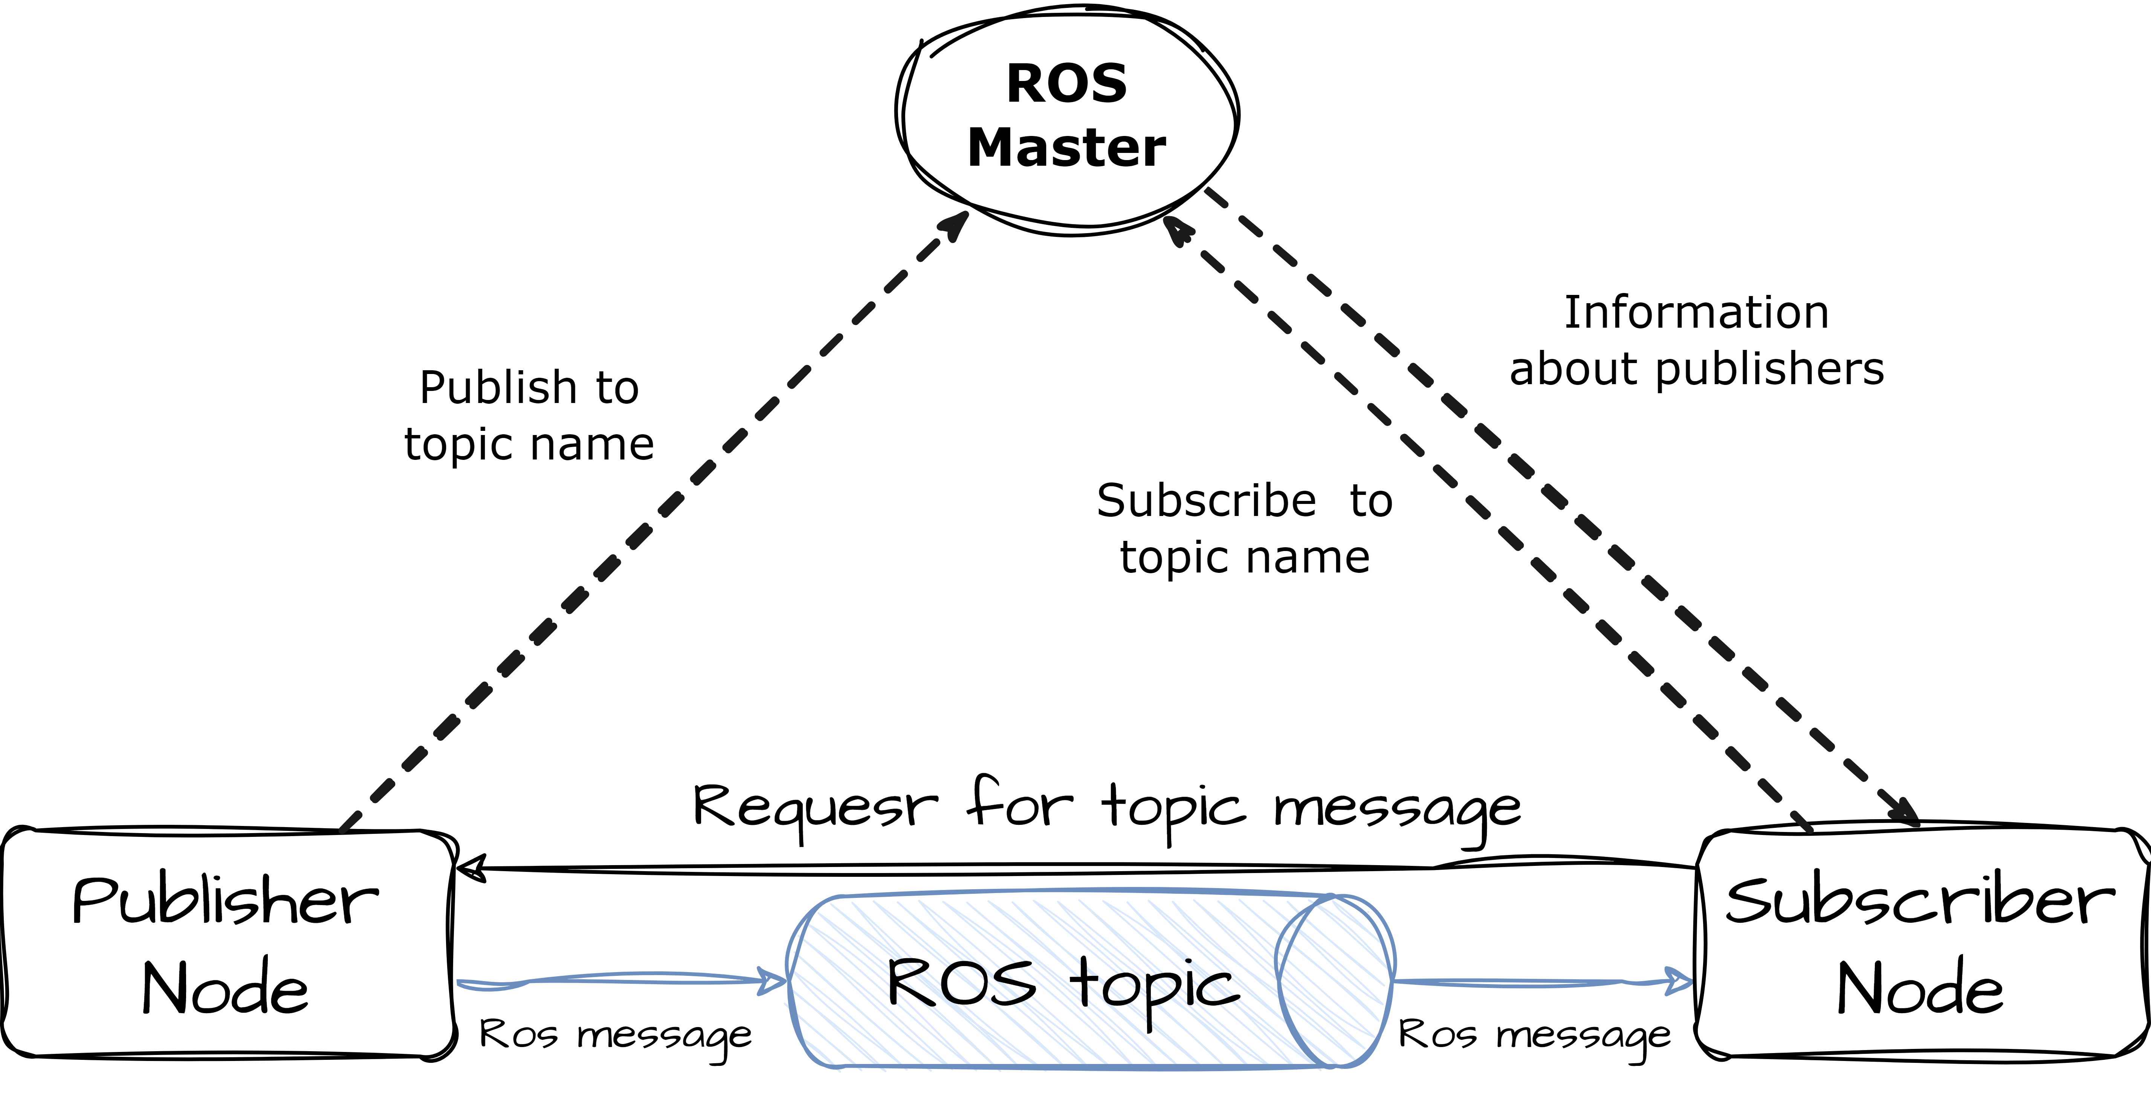

Figure : Communication in ROS

## 7.1 The Philosophical Objectives of ROS

The philosophical objectives of ROS can be succinctly described as follows[5]:

* Decentralized collaboration: Emphasizing **peer-to-peer** interactions.
* **Tool-oriented** approach: Focusing on the development of a robust set of tools.
* **Multilingual support**: Enabling compatibility with multiple programming languages.
* **Thin** design: Prioritizing a streamlined framework.
* Openness and freedom: Being freely available and based on **open-source** principles.

To the best of our knowledge, no existing framework encompasses this specific set of design principles. This section aims to delve into these philosophies, elucidating how they have profoundly influenced the design and implementation of ROS.[6]

### Peer-to-Peer

A ROS-based system is composed of various processes, which can be distributed across multiple hosts and connected in a peer-to-peer arrangement during runtime. While centralized server-based frameworks can also achieve the benefits of a multi-process and multi-host design, using a central data server poses challenges in a heterogeneous network.

For instance, in the case of large service robots designed for ROS, several onboard computers are typically connected via ethernet. This network segment is bridged wirelessly to high-power offboard machines responsible for computationally intensive tasks like computer vision and speech recognition. Placing the central server either onboard or offboard would result in unnecessary traffic traversing the (slower) wireless link since many message routes remain within the onboard or offboard subnets. In contrast, employing peer-to-peer connectivity along with buffering or "fanout" software modules when needed completely mitigates this concern.

To facilitate the peer-to-peer topology, a lookup mechanism known as the name service or master is required, enabling processes to discover each other dynamically at runtime. In the subsequent section, we will delve into the name service in more detail, elucidating its functioning and significance within the ROS framework.

### Multi-lingual

When it comes to writing code, individuals often have their own preferences for certain programming languages based on various factors such as programming time, ease of debugging, syntax, and runtime efficiency. These preferences are influenced by technical and cultural considerations, leading to personal trade-offs. In light of this, we have designed ROS to be language-neutral, accommodating different programming languages. Currently, ROS supports four distinct languages: C++, Python, Octave, and LISP, with ongoing development for ports in other languages.

The focus of the ROS specification lies at the messaging layer, rather than delving deeper into the system. Peer-to-peer connection negotiation and configuration take place using XML-RPC, which has reasonable implementations available in most widely used languages. Instead of providing a C-based implementation with generated stub interfaces for all major languages, our approach involves natively implementing ROS in each target language, ensuring adherence to language-specific conventions. However, in certain cases, it is expedient to add support for a new language by wrapping an existing library. For instance, the Octave client is implemented by wrapping the ROS C++ library.

To facilitate cross-language development, ROS employs a simple and language-neutral interface definition language (IDL) to describe the messages exchanged between modules. The IDL utilizes concise text files to define the fields of each message and allows for message composition. As an illustration, the complete IDL file provided showcases a point cloud message comprising:

Header header

Point32[] pts

ChannelFloat32[] chan

For each supported language, code generators are employed to produce native implementations that seamlessly integrate with the language's conventions, making them feel like native objects. These implementations are automatically serialized and deserialized by ROS when messages are transmitted and received. This approach significantly saves programming time and minimizes errors. To illustrate, the previously mentioned 3-line IDL file expands automatically to 137 lines of C++, 96 lines of Python, 81 lines of Lisp, and 99 lines of Octave. By generating messages automatically from concise text files, it becomes effortless to introduce new message types. As of now, the ROS-based codebases consist of over four hundred distinct message types, facilitating the transportation of various data, including sensor feeds, object detections, and maps.

The outcome of this approach is a language-neutral message processing system that allows for the seamless integration and combination of different programming languages as desired. This flexibility enables developers to leverage the strengths of different languages while maintaining compatibility and interoperability within the ROS framework.

### Tool-oriented

To effectively handle the complexity of ROS, we have adopted a microkernel design approach that relies on a multitude of small tools. Rather than constructing a monolithic development and runtime environment, this design philosophy emphasizes the utilization of these tools to build and execute different components of ROS.

These tools fulfil a range of functions, including navigating the source code tree, managing configuration parameters, visualizing the peer-to-peer connection topology, measuring bandwidth utilization, graphically plotting message data, generating documentation automatically, and more. While it would have been possible to integrate core services like a global clock and a logger within the master module, our aim has been to distribute these functionalities across separate modules. We firmly believe that although there may be a slight loss in efficiency, the benefits in terms of stability and complexity management far outweigh this trade-off.

### Thin

In robotics software projects, reusable code components like drivers and algorithms often become entangled with the middleware, hindering their extraction for reuse outside the project. To address this, ROS encourages the development of standalone libraries without dependencies on ROS. This "thin" approach, facilitated by the ROS build system and CMake, separates complexity into libraries and exposes their functionality to ROS through small executables. This enables easier code extraction, promotes reusability, and simplifies unit testing. Additionally, ROS leverages code from other open-source projects while minimizing wrapping or patching, ensuring easy integration, and benefiting from community improvements.

### Free and Open-Source

The complete source code of ROS is publicly accessible, and we consider this transparency essential for facilitating debugging across all levels of the software stack. While proprietary environments like Microsoft Robotics Studio and Webots have their merits, we firmly believe that an entirely open platform is irreplaceable. This is particularly crucial when simultaneously designing and debugging hardware and multiple layers of software.

ROS is released under the BSD license, permitting the development of both non-commercial and commercial projects. It employs inter-process communications to facilitate data exchange between modules, eliminating the requirement for modules to be linked together within the same executable. Consequently, systems built around ROS have the flexibility to incorporate components with varying licenses, ranging from GPL to BSD to proprietary. However, licensing restrictions remain confined to the boundaries of individual modules, preventing any "contamination" of licenses beyond those boundaries.

## 7.2 Moveit

MoveIt! serves as the primary software framework within ROS for motion planning and mobile manipulation. It has achieved successful integration with various robots, including the PR2, Robonaut, and DARPA's Atlas robot. MoveIt! is predominantly implemented in C++, but it also provides Python bindings for higher-level scripting. In line with the principles advocated for robotics, MoveIt! ensures software reuse by establishing a clear distinction between core functionality and framework-dependent aspects, such as component communication. By default, MoveIt! leverages the core ROS build and messaging systems. To facilitate easy component interchangeability, MoveIt! employs plugins for most of its functionalities. This includes motion planning plugins (currently utilizing OMPL), collision detection (currently utilizing the Fast Collision Library (FCL)), and kinematics plugins (currently utilizing the OROCOS Kinematics and Dynamics Library (KDL)) for generic arm forward and inverse kinematics, along with custom plugins). Section 4.3 further discusses the flexibility of modifying these default planning components[7]. MoveIt! primarily targets manipulation (and mobile manipulation) applications across industrial, commercial, and research environments. For a more comprehensive overview of MoveIt![8].

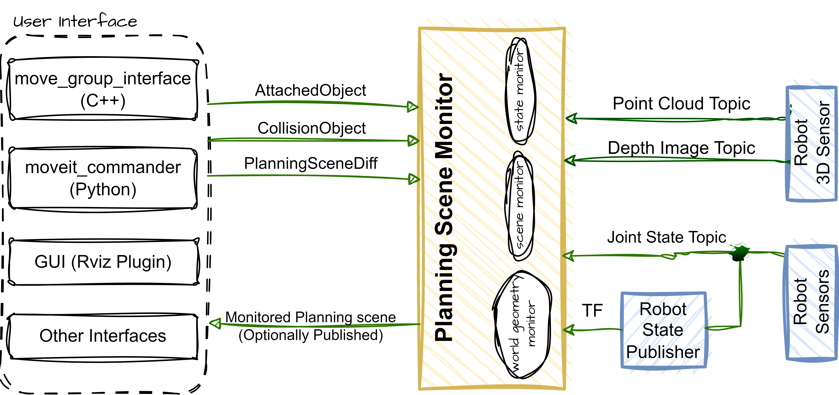

Figure : The Planning Scene in MoveIt!

As shown in *Figure 5* above, the planning scene serves as a representation of the robot's surrounding environment and retains information about the robot's current state. It is managed by the planning scene monitor within the move group node. The planning scene monitor actively listens to three types of information:

1. **State Information**: This includes updates on the joint states of the robot, which are obtained from the joint_states topic.
2. **Sensor Information**: The planning scene monitor gathers data from sensors through the world geometry monitor, which is further described below.
3. **World Geometry Information**: Users can input world geometry information through the planning scene topic, which is treated as a planning scene diff and used to update the planning scene accordingly.

*Figure 6* depicts the move_group node, which serves as an integrator, bringing together various components to offer a set of ROS actions and services for user interaction. Users can access these actions and services through three different interfaces[9]:

* **C++ Interface**: The move_group_interface package provides a straightforward C++ interface for easy setup and utilization of move_group.
* **Python Interface**: The moveit_commander package enables users to access move_group functionalities through Python.
* **GUI Interface**: Users can also employ the Motion Planning plugin in Rviz, the ROS visualizer, to interact with move_group through a graphical user interface.

To configure move_group, the ROS param server is utilized to obtain essential information. This includes:

1. **URDF**: move_group retrieves the URDF (Unified Robot Description Format) for the robot by searching for the robot_description parameter on the ROS param server.
2. **SRDF**: The robot_description_semantic parameter on the ROS param server contains the SRDF (Semantic Robot Description Format) for the robot. The SRDF is typically generated by users using the MoveIt Setup Assistant.
3. **MoveIt Configuration**: Specific configuration details for MoveIt, such as joint limits, kinematics, motion planning, and perception information, are stored on the ROS param server. Configuration files for these components are automatically generated by the MoveIt Setup Assistant and stored in the config directory of the corresponding MoveIt configuration package for the specific robot.

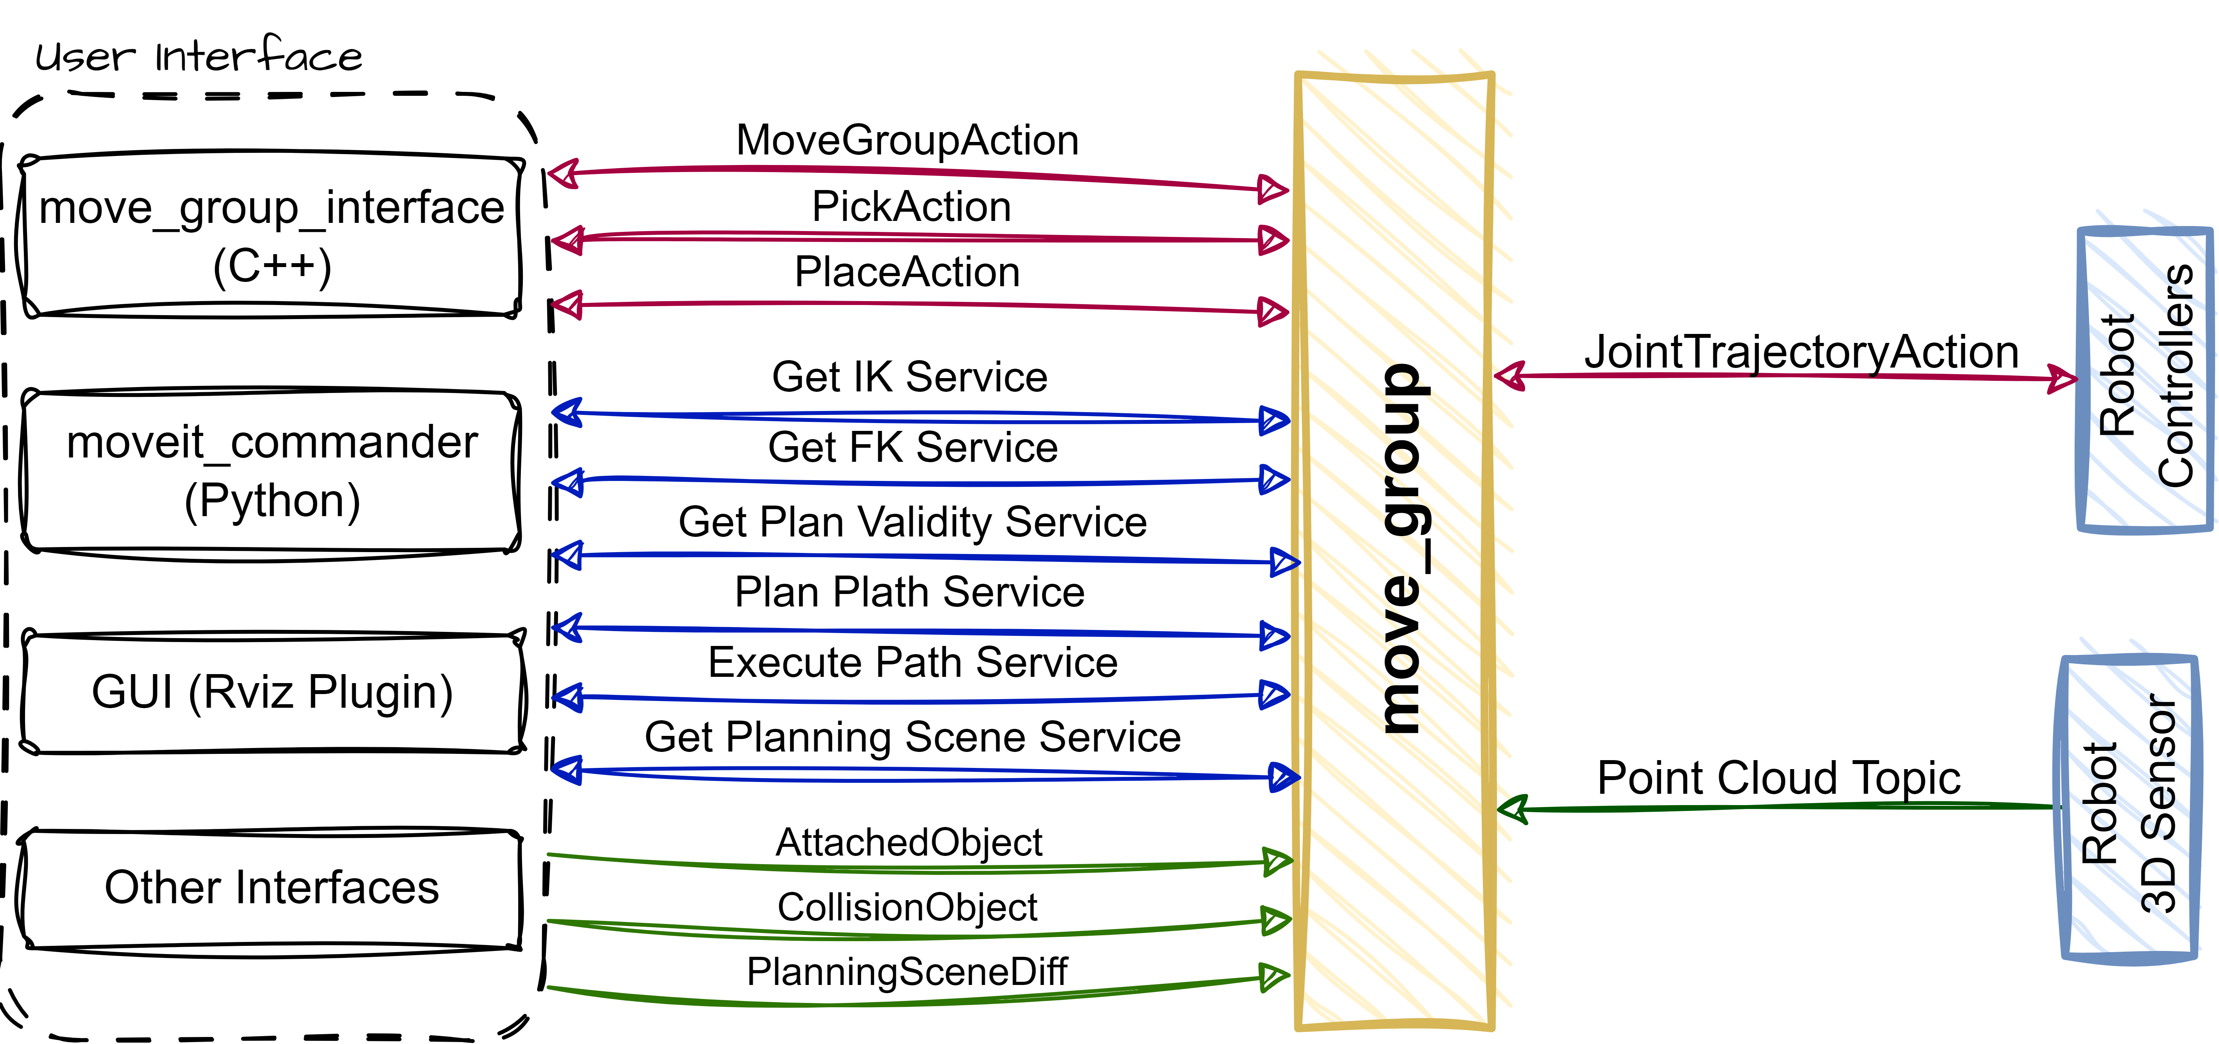

Figure : Move_group Node in MoveIt!

# 8 1st Automation Python Program Using Moveit_commander & Tkinter

Activity 3 represents a significant milestone in the internship program, focusing on the development of an automation program for the Niryo 2 robotic arm using the Moveit framework and the tkinter package for creating a graphical user interface (GUI). This activity combines the power of motion planning provided by Moveit with the versatility of tkinter to create an intuitive and interactive control interface.

The core component of this activity is the utilization of the Moveit_commander library, a purpose-built Python library designed to facilitate seamless interaction with the Moveit framework. This library provides a high-level interface for controlling the robotic arm, enabling the execution of complex motion trajectories, joint configurations, and end-effector poses. By leveraging the Moveit_commander library, the automation program can communicate with the Niryo 2 robotic arm, translating user commands into precise and coordinated movements[10].

Furthermore, this activity incorporates the tkinter package, a popular Python library for creating graphical user interfaces. Tkinter provides a rich set of tools and widgets that enable the creation of visually appealing and user-friendly GUIs. With tkinter, the automation program can present a comprehensive control panel to the user, offering intuitive controls, real-time visual feedback, and status updates. The GUI enhances the user experience by providing a seamless and interactive means of commanding the Niryo 2 robotic arm[11].

Throughout the development process, the activity covers various aspects, including designing the GUI layout, implementing event handling mechanisms, integrating the Moveit framework with the GUI, and ensuring synchronization between the interface and the robot's actions. Attention is given to designing an ergonomic and intuitive interface that enables users to perform tasks such as motion planning, trajectory execution, and monitoring of the robot's state effortlessly.

By combining the Moveit framework and tkinter, this activity demonstrates the seamless integration of motion planning capabilities with a user-friendly interface. The resulting automation program empowers users to control the Niryo 2 robotic arm efficiently, perform complex manipulation tasks, and visualize the robot's movements in real-time.

In the subsequent sections, we will explore the implementation details of Activity 3, including the design considerations, code structure, and the interplay between the Moveit_commander library and tkinter. The discussion will provide valuable insights into the development process and highlight the contributions of Moveit and tkinter in creating an effective and interactive automation program for the Niryo 2 robotic arm.

## 8.1 Dependences

The program had many dependences as we did use many libraries, services, and message types.

#!/usr/bin/env python

# General packages

import tkSimpleDialog as simpledialog

import Tkinter as tk

import ttk

from ttkthemes import ThemedTk

from PIL import ImageTk, Image

import tf

import os

# ROS

import rospy

# Services

from niryo_robot_arm_commander.srv import GetFK, GetFKRequest, GetIK, GetIKRequest

from tools_interface.srv import ToolCommand, ToolCommandRequest

from niryo_robot_msgs.srv import SetBool, SetBoolRequest, SetInt, SetIntRequest, Trigger

# Messages

from geometry_msgs.msg import Pose

from sensor_msgs.msg import JointState

from niryo_robot_msgs.msg import RobotState

import moveit_msgs.msg

import actionlib

# moveit_library

import moveit_commander

## 8.2 Graphical User Interface through tkinter

In its initial phase, the User interface was limited in functionality, offering basic automation features. The GUI underwent several stages of development, which can be summarized into four key stages. The first and second stages primarily involved the implementation of the following simple code to create the GUI, with not much any organisation at all, as shown in *Figure 7 - 8* below:

import Tkinter as tk

root = tk.Tk()

root.title("FX UR3e Controller")

root.geometry('(Chand, 2022)x(Chand, 2022)'.format(1800,800))

root.state('normal')

left_frame = tk.Frame(root, width=60)

left_frame.pack(fill=tk.Y)

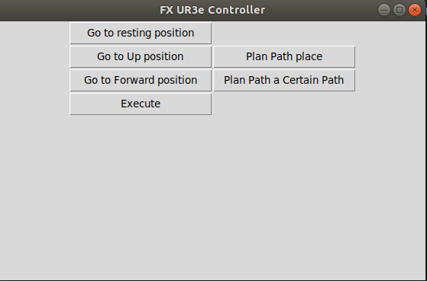

Figure : Initial Stage of the GUI

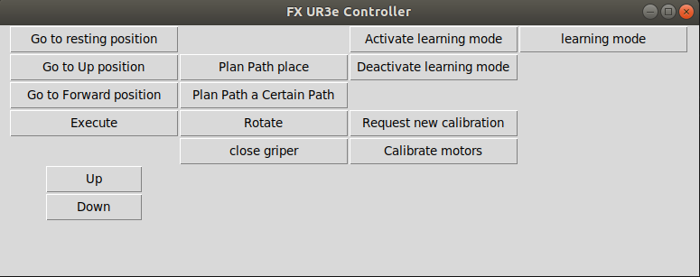

Figure : Second Stage of the GUI

Whereas, starting from 3rd stage, the GUI started look more organised, and to have more functionalities, as shown in *Figure 9* below.

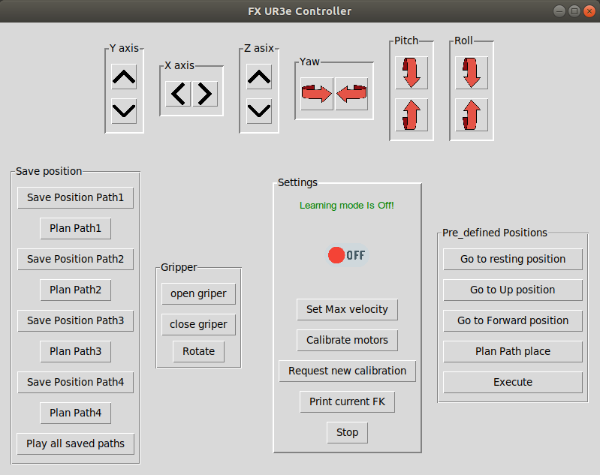

Figure : Third Stage of the GUI

Lastly, we reach the final stage, where all the functions, layout, and aesthetically pleasing themes are incorporated into the GUI, resulting in the creation of a comprehensive Graphical User Interface. Refer to *Figure 10* below to visualize the completed GUI.

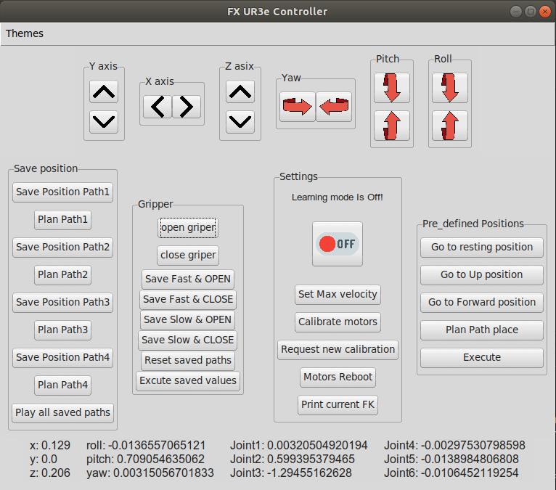

Figure : Final Stage in the GUI

Additionally, we offer the flexibility to modify the existing GUI layout by accessing the "Themes" menu located in the top-left corner of the GUI. For detailed insights into the implementation code for this updated GUI, please refer to *Appendix A: Initialization of GUI with tkinter*, located at the end of this report.

## 8.3 Functions & Buttons

In this section, I will initially highlight some of the essential functions within the code. However, for a comprehensive understanding of the GUI's construction, including its functions and buttons, please refer to *Appendix B*, which contains the complete code.

### 8.3.1 Motor Calibration

Within this particular function, I invoked the ROS service '/niryo_robot/joints_interface/calibrate_motors' that is provided by Niryo. This service is utilized to initiate motor calibration, and the value of 1 is passed as a parameter to execute the calibration process.

def calibration():

    """Give a value of 1 to the service responsible for auto calibration"""

    rospy.wait_for_service('/niryo_robot/joints_interface/calibrate_motors')

    service = rospy.ServiceProxy('/niryo_robot/joints_interface/calibrate_motors', SetInt)

    request = SetIntRequest()

    request.value = 1

    response = service(request)

    if response.success:

        rospy.loginfo("Service call succeeded")

    else:

        rospy.logerr("Service call failed")

# Button for Motors calibration.

cal_Btn = ttk.Button(settings_frame,text="Calibrate motors", command=calibration)

cal_Btn.pack(pady = 5)

### 8.3.2 requiest a new calibration

def request_calibration():

    """Request a new calibration"""

    rospy.wait_for_service('/niryo_robot/joints_interface/request_new_calibration')

    service = rospy.ServiceProxy('/niryo_robot/joints_interface/request_new_calibration', Trigger)

    response = service()

### 8.3.3 Get Joints & Pose values

The subsequent pair of functions are responsible for subscribing to and extracting information from two different topics: '/Joint_states' and 'niryo_robot/robot_state'. The purpose of subscribing to the '/Joint_states' topic is to retrieve joint values, while the 'niryo_robot/robot_state' topic is utilized to obtain pose values.

def Get_joints():

    """subscribe to the topic /Joint_states and take the joints' values"""

    msg = rospy.wait_for_message('/joint_states', JointState)

    joints = msg.position

    # return a tuple of 6 value for each joint from 1 till 8.

    return joints

def get_pose():

    """

    @argm: None

    return a RobotState message type, like the following:

position:

  x: ------

  y: ------

  z: ------

rpy:

  roll: ------

  pitch: ------

  yaw: ------

    """

    msg = rospy.wait_for_message('/niryo_robot/robot_state', RobotState)

    return msg

def get_pose_list():

    """

    return the current pose as a list:

    [x, y, z, roll, pitch, yaw]

    """

    value = get_pose()

    p = value.position

    rpy = value.rpy

    return [p.x, p.y, p.z, rpy.roll, rpy.pitch, rpy.yaw]

### 8.3.4 Moving Pose in each Axis

Once the current pose and joint values have been acquired, we have the flexibility to manipulate each axis according to our requirements. In the provided code snippet, I have demonstrated an example of moving the z-axis upwards by approximately 20mm. For further insights into the movement of each axis, please refer to the complete code available in *Appendix B*.

def Up_z():

    """Increase the value of Z-axis"""

    global Plan

    FK = get_pose()

    rpy = FK.rpy

    p = FK.position

    pose = Pose()

    z = p.z

    z += 0.02

    pose.position.x = p.x

    pose.position.y = p.y

    pose.position.z = z

    pose.orientation.x, pose.orientation.y, pose.orientation.z, pose.orientation.w = tf.transformations.quaternion_from_euler(rpy.roll, rpy.pitch, rpy.yaw)

    arm.set_goal_tolerance(0.01)

    arm.set_pose_target(pose)

    Plan = arm.plan()

    Update_position()

# To excute the planed rotation.

    arm.execute(Plan,wait=True)

up_img = ImageTk.PhotoImage(Image.open(path + "/up-arrow.png").resize((30,30)),Image.ANTIALIAS)

down_img = ImageTk.PhotoImage(Image.open(path + "/down-arrow.png").resize((30,30)),Image.ANTIALIAS)

up_z = ttk.Button(Z_axis_frame, image=up_img, command=Up_z)

up_z.pack(pady = 5)

### 8.3.5 Plan a Pre-Saved Positions & Execute it

def GoHomebtnClick():

    """Plan the the pre-saved position called resting"""

    global Plan

    arm.set_goal_tolerance(0.01)

    arm.set_named_target("resting")

    Plan = arm.plan()

GoHomebtn = ttk.Button(preset_frame,text="Go to resting position",width=20, command=GoHomebtnClick)

GoHomebtn.pack(pady=5)

def ExecutebtnClick():

    """Execute the planed path in the global variable Plan"""

    global Plan

    arm.execute(Plan,wait=True)

    Update_position()

# 9 Building a GENERAL-PURPOSE FLUXANA Ros library

The concept of creating a versatile ROS library emerged with the aim of streamlining the development process of a more intricate Graphical User Interface (GUI) and incorporating advanced functionalities into it.

For full documentation of the whole library code, check appendix C

## 9.1 Most important functions

Mostly, the functions in this library are made to reduce the complexity and redundancy of the code when building the GUI for the power dosage task.

### 9.1.1 Subscribe to a ROS-Topic

def Subscribe(topic_name, type, msg_args):

    """

    Subscribe to certain topic.

    Paramters:

    ........................

    topic_name: str

    type: srv

    msg_args: list >> list of strings, which contains the aguments that we need to read from the topic.

    Returns:

    ........................

    Return a list of the readed values from each argument.

    If we have only one argument, it returns the value of this agument only, not a list.

    """

    #rospy.init_node('FX_ROS_Subscriber')

    msg = rospy.wait_for_message(topic_name, type)

    value = []

    if len(msg_args) == 1:

        value = getattr(msg, msg_args[0])

    else:

        for i in msg_args:

            value.append(getattr(msg, i))

    return value

### 9.1.2 Call a ROS-Service

def Call_Aservice(service_name, type, request_name=None, req_args=None, should_return=None):

    """

Paramters:

    service_name: str

    type: srv

    request_name: None (srv)

    req_args: None (dictionary) ex. {'positon': 210, 'id': 11, 'value': False}

    should_return ?: None (int) >> is set to 1, if you want to return the reponse of the service.

    Returns:

    ........................

    If should_return is set to 1, the function is going to return the response of the service.

    Otherwise, the function should only call the service to do a certain action with no return.

    """

    try:

        rospy.wait_for_service(service_name, 2)

    except (rospy.ServiceException, rospy.ROSException) as e:

        rospy.logerr("Timeout and the Service was not available : " + str(e))

        return RobotState()

    try:

        service_call = rospy.ServiceProxy(service_name, type)

        if request_name == None:

            response = service_call()

        else:

            request = request_name()

            for key, value in req_args.items():

                method = setattr(request, key, value)

            response = service_call(request)

    except rospy.ServiceException as e:

        rospy.logerr("Falied to use the Service")

        return RobotState()

    if should_return == 1:

         return response

### 9.1.3 Get Current position values

#### 9.1.3.1 Get joints values

def Get_joints():

    """return a tuple of 6 value for each joint from 1 till 6"""

    joints_values = Subscribe('/joint_states', JointState, ["position"])

    return joints_values

#### 9.1.3.2 Get Pose Values

def get_pose():

    """

    Return:

    ..................................

    a list of two dictionaries, the first is positions (x,y,z),

    whereas the second is the rpy (roll, pitch, yaw)

    """

    return Subscribe('/niryo_robot/robot_state', RobotState, ['position', 'rpy'])

def get_pose_list():

    """

    Return:

    ............................

    A list of floats >>> [x, y, z, roll, pitch, yaw]

    """

    pose = get_pose()

    position = pose[0]

    rpy = pose[1]

    return [position.x, position.y, position.z, rpy.roll, rpy.pitch, rpy.yaw]

### 9.1.4 use forward kinematics solver from moveit

def FK_Moveit(joints):

    """

    Get Forward Kinematics from the MoveIt service directly after giving joints

    :param  joints

    :type   joints: list of joints values

    :return: A Pose state object

    @example of a return

position:

  x: 0.278076372862

  y: 0.101870353599

  z: 0.425462888681

orientation:

  x: 0.0257527874589

  y: 0.0122083384395

  z: 0.175399274203

  w: 0.984084775322

    """

    rospy.wait_for_service('compute_fk', 2)

    moveit_fk = rospy.ServiceProxy('compute_fk', GetPositionFK)

    fk_link = ['base_link', 'tool_link']

    header = Header(0, rospy.Time.now(), "world")

    rs = RobotStateMoveIt()

    rs.joint_state.name = ['joint_1', 'joint_2', 'joint_3', 'joint_4', 'joint_5', 'joint_6']

    rs.joint_state.position = joints

    reponse = moveit_fk(header, fk_link, rs)

    return reponse.pose_stamped[1].pose

### 9.1.5 Moving the arm

def move_to_joints(joints):

"""

Parameters:

    joints: list or tuble -> [joint1, joint2, joint3, joint4, joint5, joint6]

    """

    joints_limits = Get_Joints_limits()

    for i in range(6):

        if joints_limits.joint_limits[i].max < joints[i] or joints[i] < joints_limits.joint_limits[i].min:

            print("The joint{} can not be more than {} neither less than {}".format(i+1, joints_limits.joint_limits[i].max, joints_limits.joint_limits[i].min))

            return

        else:

            pass

    arm.go(joints, wait=True)

    arm.stop()

def Move_to_pose(pose_values):

"""

Parameters:

    pose_values: list or tuble -> [x, y, z, roll, pitch, yaw]

    """

    pose = Pose()

    p_goal = pose.position

    orn_goal = pose.orientation

    p_goal.x = pose_values[0]

    p_goal.y = pose_values[1]

    p_goal.z = pose_values[2]

    roll = pose_values[3]

    pitch = pose_values[4]

    yaw  = pose_values[5]

    orn_goal.x, orn_goal.y, orn_goal.z, orn_goal.w = tf.transformations.quaternion_from_euler(roll,pitch,yaw)

    arm.set_pose_target(pose)

    arm = arm.go(wait=True)

    arm.stop()

    arm.clear_pose_targets()

# 10 Results and Discussion

## 1st experiment

The results of the first experiment, presented in *Figure 8*, indicate an average error value of approximately 5 mm in each axis, with a maximum error of around 10 mm. These findings raise concerns, particularly in the context of repetitive tasks, for the following reasons:

* In our powder-dosage task, a higher level of precision and system robustness is required to ensure accurate and consistent dosing.
* In tasks that involve repeated movements, the cumulative effect of even a small error in each axis can lead to a significant compound error over time.
* A substantial compound error can result in a completely different endpoint after a certain number of repetitions, jeopardizing the overall accuracy and reliability of the system.

These observations underscore the importance of addressing and minimizing errors to achieve the necessary precision and stability for repetitive tasks, such as the powder-dosage task. Further analysis and improvements are crucial to mitigate these concerns and enhance the performance of the system.

To address these precision issues and further improve the system, a second experiment was conducted. The purpose of this experiment was to delve into the root causes of the errors observed in the first experiment and implement measures to enhance the overall precision. The results and analysis of this subsequent experiment will be presented in the following sections, with the aim of mitigating the identified challenges and achieving the desired level of accuracy for repetitive tasks like the powder-dosage task.

## Visualising the results from 2nd experiment:

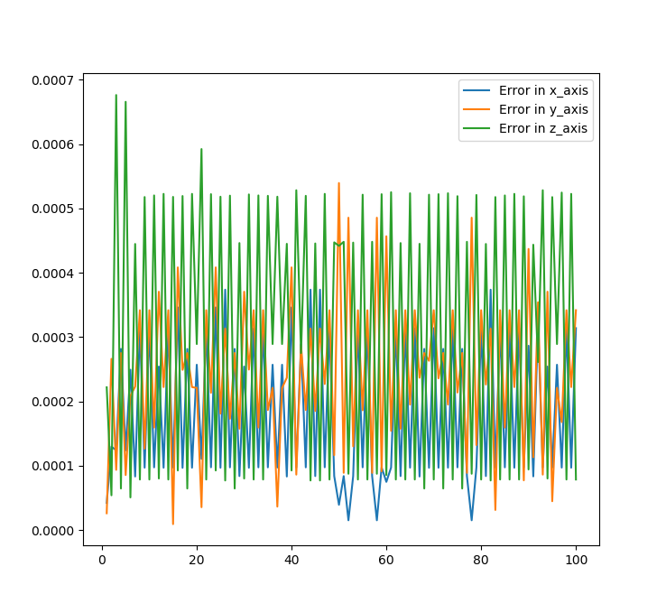

Figure : The errors result graph for the 2nd experiment after 100 iterations.

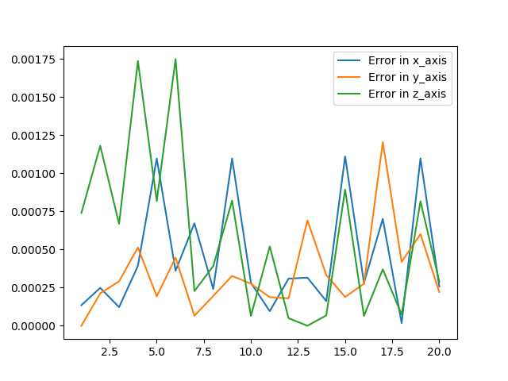

Figure : The errors result graph for the 2nd experiment after 20 iterations.

*Figure 20* displays a plot that encompasses the following characteristics:

* It visualizes the errors observed in the x, y, and z axes, allowing for a comprehensive assessment of precision.
* The x-axis of the graph corresponds to the trial number, indicating the sequence of experiments conducted.
* Meanwhile, the y-axis represents the error measured in meters (m), providing a quantitative measure of the deviations observed in each trial.

The error observations derived from the graph analysis are as follows:

* The plot reveals that the largest error recorded in the Z-axis was approximately 0.7 mm, occurring only twice out of the 100 iterations.
* In the Y-axis, a maximum error of around 0.5 mm was observed, which was recorded only once.
* The X-axis exhibited a maximum error of less than 0.4 mm, occurring a few times, with an average error of approximately 0.2 mm.
* The mean error across all axes was calculated to be approximately 0.3 mm.

These findings indicate a significant improvement in precision compared to the previous experiment, demonstrating the effectiveness of the implemented measures. The reduced errors, particularly in the Z-axis, contribute to enhanced accuracy and reliability in repetitive tasks. Further analysis and discussion will be presented in subsequent sections to fully comprehend the implications of these results and to optimize the system's performance for demanding applications like the powder-dosage task.

A visualisation of the accuracy improvement is shown in *Figure 21* below.

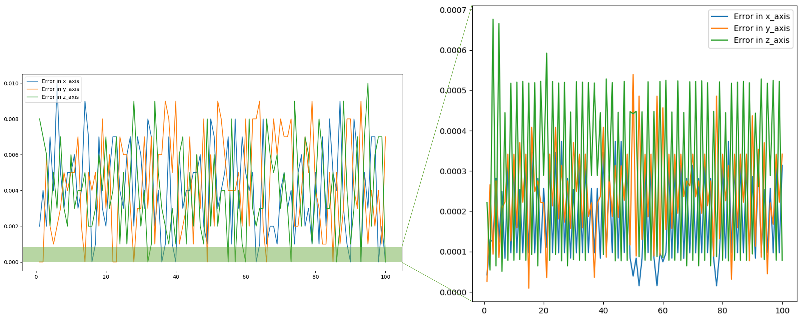

Figure : Visualization of the precision improvement

# 11 CONCLUSIONS

In conclusion, the experimentation and analysis conducted in this study have yielded promising results in improving the precision of the Niryo robot for the powder-dosage task. The initial experiment revealed an average error of approximately 5 mm in each axis, with a maximum error of around 10 mm. These findings raised significant concerns regarding the accuracy and reliability required for repetitive tasks.

However, through the implementation of specific measures and subsequent analysis, the second experiment demonstrated a substantial improvement in precision. The maximum error recorded in the Z-axis was reduced to approximately 0.7 mm, occurring only twice out of the 100 iterations. In the Y-axis, a maximum error of around 0.5 mm was observed, recorded only once. The X-axis exhibited a maximum error of less than 0.4 mm, occurring sporadically, with an average error of approximately 0.2 mm. The mean error across all axes was calculated to be around 0.3 mm.

This represents a percentage improvement of 93% in precision compared to the initial experiment. Although further refinements may be necessary, the achieved level of precision is considered acceptable for the desired powder dosage task at this stage. The reduced errors, particularly in the Z-axis, contribute significantly to enhancing the accuracy and reliability of the robot's movements.

While the achieved precision meets the current requirements for the powder-dosage task, it is essential to remain vigilant and continually strive for even greater accuracy. As the task demands high precision and repeatability, ongoing research and development efforts should focus on optimizing control algorithms, refining calibration techniques, and exploring advanced methodologies to further enhance the system's performance.

In conclusion, the significant improvement in precision, with a percentage improvement of 93%, demonstrates the effectiveness of the implemented measures. The current level of accuracy, although acceptable for the desired powder dosage task, serves as a foundation for future advancements, ensuring the successful execution of tasks requiring high levels of accuracy and repeatability.

# References

Chand, P. (2022). *Developing a Matlab Controller for Niryo Ned Robot.* Paper presented at the 2022 1st International Conference on Technology Innovation and Its Applications (ICTIIA).

Chitta, I. A. S. u. a. S. (2013). Moveit! Retrieved from <http://moveit.ros.org/>

Chitta, S., Sucan, I., & Cousins, S. (2012). Moveit![ros topics]. *IEEE Robotics & Automation Magazine, 19*(1), 18-19.

Quigley, M., Conley, K., Gerkey, B., Faust, J., Foote, T., Leibs, J., . . . Ng, A. Y. (2009). *ROS: an open-source Robot Operating System.* Paper presented at the ICRA workshop on open source software.

St-Onge, D., & Herath, D. (2022). The Robot Operating System (ROS1 &2): Programming Paradigms and Deployment. In *Foundations of Robotics: A Multidisciplinary Approach with Python and ROS* (pp. 105-126): Springer.

Stonebank, M. (2000). Unix tutorial one. Retrieved from <http://www.ee.surrey.ac.uk/Teaching/Unix/>

# Appendix

|  |  |
| --- | --- |
| Section | Description |
| A | Initialization code of GUI with tkinter |
| B | Full code of the GUI used to PRESENT Niryo at hsrw event. |
| C | FX_ROS library |

## Appendix A: Initialization of GUI with tkinter, using python 2.7

import Tkinter as tk

import ttk

from ttkthemes import ThemedTk

root = ThemedTk()

root.title("FX UR3e Controller")

# Set the size of the GUI window

root.geometry('(Chand, 2022)x{}'.format(800,800))

# Set the initial state of the GUI window

root.state('normal')

# Create a frame to hold the top section of the GUI window

Top_frame = ttk.Frame(root)

Top_frame.pack(fill=tk.Y, side="top")

# Create a frame to hold the middle section of the GUI window

Middle_frame = ttk.Frame(root)

Middle_frame.pack(fill=tk.Y, side="top")

# Create a frame to hold the bottom section of the GUI window

Bottom_frame = ttk.Frame(root)

Bottom_frame.pack(fill=tk.Y, side="top")

# Create a frame to hold the pre-defined positions buttons

preset_frame = ttk.LabelFrame(Middle_frame, text="Pre_defined Positions")

preset_frame.pack(padx=10, pady=10, side="right")

# Create a frame to hold the settings buttons

settings_frame = ttk.LabelFrame(Middle_frame, text="Settings", relief = tk.RAISED)

settings_frame.pack(padx=10, pady=10, side="right")

# Create a frame to hold the motion buttons

motion_frame = ttk.LabelFrame(Middle_frame, text="Motion")

motion_frame.pack(padx=10, pady=10, side="right")

# Create a frame to hold the save position button

save_frame = ttk.LabelFrame(Middle_frame, text="Save position")

save_frame.pack(padx=10, pady=10, side="left")

# Create a frame to hold the Roll joint controls

roll_frame = ttk.LabelFrame(Top_frame, text="Roll", relief = tk.SUNKEN)

roll_frame.pack(padx=10, pady=10, side="right")

# Create a frame to hold the Pitch joint controls

pitch_frame = ttk.LabelFrame(Top_frame, text="Pitch", relief = tk.SUNKEN)

pitch_frame.pack(padx=10, pady=10, side="right")

# Create a frame to hold the Yaw joint controls

yaw_frame = ttk.LabelFrame(Top_frame, text="Yaw", relief = tk.SUNKEN)

yaw_frame.pack(padx=10, pady=10, side="right")

# Create a frame to hold the Z-axis joint controls

Z_axis_frame = ttk.LabelFrame(Top_frame, text="Z asix")

Z_axis_frame.pack(padx=10, pady=10, side="right")

# Create a frame to hold the X-axis joint controls

X_axis_frame = ttk.LabelFrame(Top_frame, text="X axis")

X_axis_frame.pack(padx=10, pady=10, side="right")

# Create a frame to hold the Y-axis joint controls

Y_axis_frame = ttk.LabelFrame(Top_frame, text="Y axis")

Y_axis_frame.pack(padx=10, pady=10, side="right")

# Create a frame to hold the Gripper controls

gripper_frame = ttk.LabelFrame(Middle_frame, text="Gripper")

gripper_frame.pack(padx=10, pady=10, side="left")

style = ttk.Style(root)

style.theme_use("scidsand")

# See included styles

our_themes = root.get_themes()

def changer(theme):

    style.theme_use(theme)

my_menu = tk.Menu(root)

root.config(menu=my_menu)

theme_menu = tk.Menu(my_menu, tearoff=0)

my_menu.add_cascade(label="Themes", menu=theme_menu)

#create Sub menu

for t in our_themes:

    theme_menu.add_command(label=t, command= lambda t=t: changer(t))

is_on = False

# Create Label

my_label = ttk.Label(settings_frame,

    text = "Learning mode Is Off!",

    font = ("Helvetica", 10))

my_label.pack(pady = 5)

## Appendix B: Full code of the GUI used to PRESENT Niryo at hsrw event

#!/usr/bin/env python

# General packages

import tkSimpleDialog as simpledialog

import Tkinter as tk

import ttk

from ttkthemes import ThemedTk

from PIL import ImageTk, Image

import tf

import os

# Services

from niryo_robot_arm_commander.srv import GetFK, GetFKRequest, GetIK, GetIKRequest

from tools_interface.srv import ToolCommand, ToolCommandRequest

from niryo_robot_msgs.srv import SetBool, SetBoolRequest, SetInt, SetIntRequest, Trigger

# Messages

from geometry_msgs.msg import Pose

from sensor_msgs.msg import JointState

from niryo_robot_msgs.msg import RobotState

import moveit_msgs.msg

import moveit_commander

rospy.init_node('controller')

path = os.path.expanduser('~/Documents')

path = path + "/images"

robot = moveit_commander.RobotCommander()

scene = moveit_commander.PlanningSceneInterface()

arm = moveit_commander.move_group.MoveGroupCommander("arm")

root = ThemedTk()

root.title("FX UR3e Controller")

global Plan

global Path1; Path1 = 0

global Path2; Path2 = 0

global Path3; Path3 = 0

global Path4; Path4 = 0

# Set the size of the GUI window

root.geometry('{}x{}'.format(800,800))

# Set the initial state of the GUI window

root.state('normal')

# Create a frame to hold the top section of the GUI window

Top_frame = ttk.Frame(root)

Top_frame.pack(fill=tk.Y, side="top")

# Create a frame to hold the middle section of the GUI window

Middle_frame = ttk.Frame(root)

Middle_frame.pack(fill=tk.Y, side="top")

# Create a frame to hold the bottom section of the GUI window

Bottom_frame = ttk.Frame(root)

Bottom_frame.pack(fill=tk.Y, side="top")

# Create a frame to hold the pre-defined positions buttons

preset_frame = ttk.LabelFrame(Middle_frame, text="Pre_defined Positions")

preset_frame.pack(padx=10, pady=10, side="right")

# Create a frame to hold the settings buttons

settings_frame = ttk.LabelFrame(Middle_frame, text="Settings", relief = tk.RAISED)

settings_frame.pack(padx=10, pady=10, side="right")

# Create a frame to hold the motion buttons

motion_frame = ttk.LabelFrame(Middle_frame, text="Motion")

motion_frame.pack(padx=10, pady=10, side="right")

# Create a frame to hold the save position button

save_frame = ttk.LabelFrame(Middle_frame, text="Save position")

save_frame.pack(padx=10, pady=10, side="left")

# Create a frame to hold the Roll joint controls

roll_frame = ttk.LabelFrame(Top_frame, text="Roll", relief = tk.SUNKEN)

roll_frame.pack(padx=10, pady=10, side="right")

# Create a frame to hold the Pitch joint controls

pitch_frame = ttk.LabelFrame(Top_frame, text="Pitch", relief = tk.SUNKEN)

pitch_frame.pack(padx=10, pady=10, side="right")

# Create a frame to hold the Yaw joint controls

yaw_frame = ttk.LabelFrame(Top_frame, text="Yaw", relief = tk.SUNKEN)

yaw_frame.pack(padx=10, pady=10, side="right")

# Create a frame to hold the Z-axis joint controls

Z_axis_frame = ttk.LabelFrame(Top_frame, text="Z asix")

Z_axis_frame.pack(padx=10, pady=10, side="right")

# Create a frame to hold the X-axis joint controls

X_axis_frame = ttk.LabelFrame(Top_frame, text="X axis")

X_axis_frame.pack(padx=10, pady=10, side="right")

# Create a frame to hold the Y-axis joint controls

Y_axis_frame = ttk.LabelFrame(Top_frame, text="Y axis")

Y_axis_frame.pack(padx=10, pady=10, side="right")

# Create a frame to hold the Gripper controls

gripper_frame = ttk.LabelFrame(Middle_frame, text="Gripper")

gripper_frame.pack(padx=10, pady=10, side="left")

style = ttk.Style(root)

style.theme_use("scidsand")

# See included styles

our_themes = root.get_themes()

def changer(theme):

    style.theme_use(theme)

my_menu = tk.Menu(root)

root.config(menu=my_menu)

theme_menu = tk.Menu(my_menu, tearoff=0)

my_menu.add_cascade(label="Themes", menu=theme_menu)

#create Sub menu

for t in our_themes:

    theme_menu.add_command(label=t, command= lambda t=t: changer(t))

is_on = False

# Create Label

my_label = ttk.Label(settings_frame,

    text = "Learning mode Is Off!",

    font = ("Helvetica", 10))

my_label.pack(pady = 5)

# Define our switch function

def switch():

    """Make a switch for a activating and deactivating the leaning mode"""

    global is_on

    # Determine is on or off

    if is_on:

        learning_mode_switch.config(image = off)

        my_label.config(text = "Learning mode is Off")

        is_on = False

        learning_mode(0)

    else:

        learning_mode_switch.config(image = on)

        my_label.config(text = "Learning mode is On")

        is_on = True

        learning_mode(1)

def Update_position():

    # Update the Pose lable

    Pose_posistion_label.config(text = str(get_pose().position))

    Pose_rpy_label.config(text = str(get_pose().rpy))

    # Update the Joints lable

    Joints123_label.config(text = """Joint1: {}

Joint2: {}

Joint3: {}""".format(Get_joints()[0], Get_joints()[1], Get_joints()[2]))

    Joints456_label.config(text = """Joint4: {}

Joint5: {}

Joint6: {}""".format(Get_joints()[3], Get_joints()[4], Get_joints()[5]))

# Define Our Images

on = ImageTk.PhotoImage(Image.open(path + "/switch-on.png").resize((60,60)),Image.ANTIALIAS)

off = ImageTk.PhotoImage(Image.open(path + "/switch-off.png").resize((60,60)),Image.ANTIALIAS)

# Create A Button

learning_mode_switch = ttk.Button(settings_frame, image = off,

                command = switch)

learning_mode_switch.pack(pady = 20)

def set_max_speed():

    """Takes a value from the user between 0 and 1, where 0 = 0% scaling factor of the speed,

    and 1 = 100% = full speed"""

    factor = simpledialog.askfloat("Max velocity scaling factor", "Enter a value between 0 and 1")

    arm.set_max_velocity_scaling_factor(factor)

set_speed = ttk.Button(settings_frame,text="Set Max velocity", command=set_max_speed)

set_speed.pack(pady = 5)

def request_calibration():

    """Request a new calibration"""

    rospy.wait_for_service('/niryo_robot/joints_interface/request_new_calibration')

    service = rospy.ServiceProxy('/niryo_robot/joints_interface/request_new_calibration', Trigger)

    response = service()

def Get_Joints_limits():

    """Getting the limits for each joint

    You can get any joint limits as following:

    Get_Joints_limits().joint_limits[0 - 5].max (float)

    Get_Joints_limits().joint_limits[0 - 5].min (float)

    Get_Joints_limits().joint_limits[0 - 5].name (str)

    Where 0 for (joint 1), and 5 for (joint 6)

    max, min, or name would give the maximum, minimum or name of the indicated joint"""

    rospy.wait_for_service('/niryo_robot_arm_commander/get_joints_limit')

    service = rospy.ServiceProxy('/niryo_robot_arm_commander/get_joints_limit', GetJointLimits)

    response = service()

    return response

def calibration():

    """Give a value of 1 to the service responsible for auto calibration"""

    rospy.wait_for_service('/niryo_robot/joints_interface/calibrate_motors')

    service = rospy.ServiceProxy('/niryo_robot/joints_interface/calibrate_motors', SetInt)

    request = SetIntRequest()

    request.value = 1

    response = service(request)

    if response.success:

        rospy.loginfo("Service call succeeded")

    else:

        rospy.logerr("Service call failed")

# Button for Motors calibration.

cal_Btn = ttk.Button(settings_frame,text="Calibrate motors", command=calibration)

cal_Btn.pack(pady = 5)

# Button for requesting new calibration.

req_cal_Btn = ttk.Button(settings_frame,text="Request new calibration",command=request_calibration)

req_cal_Btn.pack(pady = 5)

def Motors_reboot():

    """Reboot all motors"""

    rospy.wait_for_service('/niryo_robot_hardware_interface/reboot_motors')

    service = rospy.ServiceProxy('/niryo_robot_hardware_interface/reboot_motors', Trigger)

    response = service()

# Button for Motors rebooting.

Reboot_Btn = ttk.Button(settings_frame,text="Motors Reboot",command=Motors_reboot)

Reboot_Btn.pack(pady = 5)

up_roll_img = ImageTk.PhotoImage(Image.open(path + "/up-roll-arrow.png").resize((40,40)),Image.ANTIALIAS)

down_roll_img = ImageTk.PhotoImage(Image.open(path + "/down-roll-arrow.png").resize((40,40)),Image.ANTIALIAS)

def Roll_plus():

    """Increase the value of the roll axis"""

    global Plan

    FK = get_pose()

    rpy = FK.rpy

    p = FK.position

    pose = Pose()

    roll = rpy.roll

    roll += 0.1

    pose.position.x = p.x

    pose.position.y = p.y

    pose.position.z = p.z

    pose.orientation.x, pose.orientation.y, pose.orientation.z, pose.orientation.w = tf.transformations.quaternion_from_euler(roll, rpy.pitch, rpy.yaw)

    arm.set_goal_tolerance(0.01)

    arm.set_pose_target(pose)

    Plan = arm.plan()

    Update_position()

# To excute the planed rotation.

    arm.execute(Plan,wait=True)

roll_plus = ttk.Button(roll_frame, image=down_roll_img, command=Roll_plus)

roll_plus.pack(pady = 5)

def Roll_neg():

    """decrease the value of the roll axis"""

    global Plan

    FK = get_pose()

    rpy = FK.rpy

    p = FK.position

    pose = Pose()

    roll = rpy.roll

    roll -= 0.1

    pose.position.x = p.x

    pose.position.y = p.y

    pose.position.z = p.z

    pose.orientation.x, pose.orientation.y, pose.orientation.z, pose.orientation.w = tf.transformations.quaternion_from_euler(roll, rpy.pitch, rpy.yaw)

    arm.set_goal_tolerance(0.01)

    arm.set_pose_target(pose)

    Plan = arm.plan()

    Update_position()

    # To excute the planed rotation.

    arm.execute(Plan,wait=True)

roll_neg = ttk.Button(roll_frame, image=up_roll_img, command=Roll_neg)

roll_neg.pack(pady = 5)

def Pitch_plus():

    """Increase the value of the pitch axis"""

    global Plan

    FK = get_pose()

    rpy = FK.rpy

    p = FK.position

    pose = Pose()

    pitch = rpy.pitch

    pitch += 0.1

    pose.position.x = p.x

    pose.position.y = p.y

    pose.position.z = p.z

    pose.orientation.x, pose.orientation.y, pose.orientation.z, pose.orientation.w = tf.transformations.quaternion_from_euler(rpy.roll, pitch, rpy.yaw)

    arm.set_goal_tolerance(0.01)

    arm.set_pose_target(pose)

    Plan = arm.plan()

    Update_position()

# To excute the planed rotation.

    arm.execute(Plan,wait=True)

pitch_plus = ttk.Button(pitch_frame, image=down_roll_img, command=Pitch_plus)

pitch_plus.pack(pady = 5)

def Pitch_neg():

    """decrease the value of the pitch axis"""

    global Plan

    FK = get_pose()

    rpy = FK.rpy

    p = FK.position

    pose = Pose()

    pitch = rpy.pitch

    pitch -= 0.1

    pose.position.x = p.x

    pose.position.y = p.y

    pose.position.z = p.z

    pose.orientation.x, pose.orientation.y, pose.orientation.z, pose.orientation.w = tf.transformations.quaternion_from_euler(rpy.roll, pitch, rpy.yaw)

    arm.set_goal_tolerance(0.01)

    arm.set_pose_target(pose)

    Plan = arm.plan()

    Update_position()

    # To excute the planed rotation.

    arm.execute(Plan,wait=True)

pitch_neg = ttk.Button(pitch_frame, image=up_roll_img, command=Pitch_neg)

pitch_neg.pack(pady = 5)

right_yaw_img = ImageTk.PhotoImage(Image.open(path + "/right-yaw-arrow.png").resize((40,40)),Image.ANTIALIAS)

left_yaw_img = ImageTk.PhotoImage(Image.open(path + "/left-yaw-arrow.png").resize((40,40)),Image.ANTIALIAS)

def Yaw_plus():

    """Increase the value of Yaw axis"""

    global Plan

    FK = get_pose()

    rpy = FK.rpy

    p = FK.position

    pose = Pose()

    yaw = rpy.yaw

    yaw += 0.1

    pose.position.x = p.x

    pose.position.y = p.y

    pose.position.z = p.z

    pose.orientation.x, pose.orientation.y, pose.orientation.z, pose.orientation.w = tf.transformations.quaternion_from_euler(rpy.roll, rpy.pitch, yaw)

    arm.set_goal_tolerance(0.01)

    arm.set_pose_target(pose)

    Plan = arm.plan()

    Update_position()

# To excute the planed rotation.

    arm.execute(Plan,wait=True)

def Yaw_neg():

    """Decrease the value of Yaw axis"""

    global Plan

    FK = get_pose()

    rpy = FK.rpy

    p = FK.position

    pose = Pose()

    yaw = rpy.yaw

    yaw -= 0.1

    pose.position.x = p.x

    pose.position.y = p.y

    pose.position.z = p.z

    pose.orientation.x, pose.orientation.y, pose.orientation.z, pose.orientation.w = tf.transformations.quaternion_from_euler(rpy.roll, rpy.pitch, yaw)

    arm.set_goal_tolerance(0.01)

    arm.set_pose_target(pose)

    Plan = arm.plan()

    Update_position()

    # To excute the planed rotation.

    arm.execute(Plan,wait=True)

yaw_plus = ttk.Button(yaw_frame, image=left_yaw_img, command=Yaw_neg)

yaw_plus.pack(pady = 5, side="right")

yaw_neg = ttk.Button(yaw_frame, image=right_yaw_img, command=Yaw_plus)

yaw_neg.pack(pady = 5, side="left")

def Up_z():

    """Increase the value of Z-axis"""

    global Plan

    FK = get_pose()

    rpy = FK.rpy

    p = FK.position

    pose = Pose()

    z = p.z

    z += 0.02

    pose.position.x = p.x

    pose.position.y = p.y

    pose.position.z = z

    pose.orientation.x, pose.orientation.y, pose.orientation.z, pose.orientation.w = tf.transformations.quaternion_from_euler(rpy.roll, rpy.pitch, rpy.yaw)

    arm.set_goal_tolerance(0.01)

    arm.set_pose_target(pose)

    Plan = arm.plan()

    Update_position()

# To excute the planed rotation.

    arm.execute(Plan,wait=True)

up_img = ImageTk.PhotoImage(Image.open(path + "/up-arrow.png").resize((30,30)),Image.ANTIALIAS)

down_img = ImageTk.PhotoImage(Image.open(path + "/down-arrow.png").resize((30,30)),Image.ANTIALIAS)

up_z = ttk.Button(Z_axis_frame, image=up_img, command=Up_z)

up_z.pack(pady = 5)

def Down_z():

    """Decrease the value of Z-axis"""

    global Plan

    FK = get_pose()

    rpy = FK.rpy

    p = FK.position

    pose = Pose()

    z = p.z

    z -= 0.02

    pose.position.x = p.x

    pose.position.y = p.y

    pose.position.z = z

    pose.orientation.x, pose.orientation.y, pose.orientation.z, pose.orientation.w = tf.transformations.quaternion_from_euler(rpy.roll, rpy.pitch, rpy.yaw)

    arm.set_goal_tolerance(0.01)

    arm.set_pose_target(pose)

    Plan = arm.plan()

    Update_position()

    # To excute the planed rotation.

    arm.execute(Plan,wait=True)

down_z = ttk.Button(Z_axis_frame, image=down_img, command=Down_z)

down_z.pack(pady = 5)

right_img = ImageTk.PhotoImage(Image.open(path + "/right-arrow.png").resize((30,30)),Image.ANTIALIAS)

left_img = ImageTk.PhotoImage(Image.open(path + "/left-arrow.png").resize((30,30)),Image.ANTIALIAS)

def Right_x():

    """Increase the value of X-axis"""

    global Plan

    FK = get_pose()

    rpy = FK.rpy

    p = FK.position

    pose = Pose()

    x = p.x

    x += 0.02

    pose.position.x = x

    pose.position.y = p.y

    pose.position.z = p.z

    pose.orientation.x, pose.orientation.y, pose.orientation.z, pose.orientation.w = tf.transformations.quaternion_from_euler(rpy.roll, rpy.pitch, rpy.yaw)

    arm.set_goal_tolerance(0.01)

    arm.set_pose_target(pose)

    Plan = arm.plan()

    Update_position()

# To excute the planed rotation.

    arm.execute(Plan,wait=True)

right = ttk.Button(X_axis_frame, image=right_img, command=Right_x)

right.pack(pady = 5, side="right")

def Left_x():

    """Decrease the value of X-axis"""

    global Plan

    FK = get_pose()

    rpy = FK.rpy

    p = FK.position

    pose = Pose()

    x = p.x

    x -= 0.02

    pose.position.x = x

    pose.position.y = p.y

    pose.position.z = p.z

    pose.orientation.x, pose.orientation.y, pose.orientation.z, pose.orientation.w = tf.transformations.quaternion_from_euler(rpy.roll, rpy.pitch, rpy.yaw)

    arm.set_goal_tolerance(0.01)

    arm.set_pose_target(pose)

    Plan = arm.plan()

    Update_position()

    # To excute the planed rotation.

    arm.execute(Plan,wait=True)

left = ttk.Button(X_axis_frame, image=left_img, command=Left_x)

left.pack(pady = 5, side="left")

def Up_y():

    """Increase the value of Y-axis"""

    global Plan

    FK = get_pose()

    rpy = FK.rpy

    p = FK.position

    pose = Pose()

    y = p.y

    y += 0.02

    pose.position.x = p.x

    pose.position.y = y

    pose.position.z = p.z

    pose.orientation.x, pose.orientation.y, pose.orientation.z, pose.orientation.w = tf.transformations.quaternion_from_euler(rpy.roll, rpy.pitch, rpy.yaw)

    arm.set_goal_tolerance(0.01)

    arm.set_pose_target(pose)

    Plan = arm.plan()

    Update_position()

# To excute the planed rotation.

    arm.execute(Plan,wait=True)

up_y = ttk.Button(Y_axis_frame, image=up_img, command=Up_y)

up_y.pack(pady = 5)

def Down_y():

    """Decrease the value of Y-axis"""

    global Plan

    FK = get_pose()

    rpy = FK.rpy

    p = FK.position

    pose = Pose()

    y = p.y

    y -= 0.02

    pose.position.x = p.x

    pose.position.y = y

    pose.position.z = p.z

    pose.orientation.x, pose.orientation.y, pose.orientation.z, pose.orientation.w = tf.transformations.quaternion_from_euler(rpy.roll, rpy.pitch, rpy.yaw)

    arm.set_goal_tolerance(0.01)

    arm.set_pose_target(pose)

    Plan = arm.plan()

    Update_position()

    # To excute the planed rotation.

    arm.execute(Plan,wait=True)

down_y = ttk.Button(Y_axis_frame, image=down_img, command=Down_y)

down_y.pack(pady = 5)

def open_gripper():

    """Using the open gripper service to open the end effetor (gripper)

    with ID = 11, and the open position = 2060."""

    rospy.wait_for_service('/niryo_robot/tools/open_gripper')

    service = rospy.ServiceProxy('/niryo_robot/tools/open_gripper', ToolCommand)

    request = ToolCommandRequest()

    request.id = 11

    request.position = 2060

    request.speed = 500

    request.hold_torque = 50

    request.max_torque = 100

    response = service(request)

# Button for opening the gripper.

open_ = ttk.Button(gripper_frame,text="open griper", command=open_gripper)

open_.pack(pady=5)

def close_gripper():

    """Using the close gripper service to close the end effetor (gripper)

    with ID = 11, and the closed position = 808."""

    rospy.wait_for_service('/niryo_robot/tools/close_gripper')

    service = rospy.ServiceProxy('/niryo_robot/tools/close_gripper', ToolCommand)

    request = ToolCommandRequest()

    request.id = 11

    request.position = 807

    request.speed = 500

    request.hold_torque = 100

    request.max_torque = 100

    response = service(request)

# Button for closing the gripper.

close_ = ttk.Button(gripper_frame,text="close griper", command=close_gripper)

close_.pack(pady=5)

global all_joints; all_joints = []

def learning_mode(on_or_off=0):

    """The function takes argument 0 or 1, whereas, 1 = learning more is turned on,

    and 0 = learning mode is off."""

    rospy.wait_for_service('/niryo_robot/learning_mode/activate')

    service = rospy.ServiceProxy('/niryo_robot/learning_mode/activate', SetBool)

    request = SetBoolRequest()

    global all_joints

    if on_or_off == 1:

        request.value = True

    elif on_or_off == 0:

        request.value = False

        joints = (Get_joints())

        all_joints.append(joints)

        with open('joints_values', 'w') as joints_values:

            csv_writer = csv.writer(joints_values)

            for line in all_joints:

                csv_writer.writerow(line)

    Update_position()

    response = service(request)

def Get_joints():

    """subscribe to the topic /Joint_states and take the joints' values"""

    msg = rospy.wait_for_message('/joint_states', JointState)

    joints = msg.position

    # return a tuple of 6 value for each joint from 1 till 8.

    return joints

def get_pose():

    """

    @argm: None

    return a RobotState message type, like the following:

position:

  x: ------

  y: ------

  z: ------

rpy:

  roll: ------

  pitch: ------

  yaw: ------

orientation:

  x: ------

  y: ------

  z: ------

  w: ------

twist:

  linear:

    x: 0.0

    y: 0.0

    z: 0.0

  angular:

    x: 0.0

    y: -0.0

    z: -0.0

tcp_speed: 0.0

    """

    msg = rospy.wait_for_message('/niryo_robot/robot_state', RobotState)

    return msg

def get_pose_list():

    """

    return the current pose as a list:

    [x, y, z, roll, pitch, yaw]

    """

    value = get_pose()

    p = value.position

    rpy = value.rpy

    return [p.x, p.y, p.z, rpy.roll, rpy.pitch, rpy.yaw]

# Generate a lable for Pose positions in the bottom frame.

Pose_posistion_label = ttk.Label(Bottom_frame,

    text = str(get_pose().position),

    font = ("Helvetica", 12))

Pose_posistion_label.pack(padx=10, side="left")

# Generate a lable for Pose rpy in the bottom frame.

Pose_rpy_label = ttk.Label(Bottom_frame,

    text = str(get_pose().rpy),

    font = ("Helvetica", 12))

Pose_rpy_label.pack(padx=10, side="left")

# Generate a lable for Joints in the bottom frame.

Joints123_label = ttk.Label(Bottom_frame,

    text = """Joint1: {}

Joint2: {}

Joint3: {}""".format(round(Get_joints()[0], 6), round(Get_joints()[1], 6), round(Get_joints()[2], 6)),

    font = ("Helvetica", 12))

Joints123_label.pack(padx=10, side="left")

Joints456_label = ttk.Label(Bottom_frame,

    text = """Joint4: {}

Joint5: {}

Joint6: {}""".format(round(Get_joints()[3], 6), round(Get_joints()[4], 6), round(Get_joints()[5], 6)),

    font = ("Helvetica", 12))

Joints456_label.pack(padx=10, side="left")

def Print_current_pose():

    FK = get_pose()

    print(FK.position)

    print('\n')

    print(FK.rpy)

PrintFK = ttk.Button(settings_frame,text="Print current FK", command=Print_current_pose)

PrintFK.pack(pady=5)

def rotate():

    global Plan

    FK = get_pose()

    rpy = FK.rpy

    p = FK.position

    pose = Pose()

    pose.position.x = p.x

    pose.position.y = p.y

    pose.position.z = p.z

    roll = rpy.roll

    pitch = rpy.pitch

    yaw = rpy.yaw

    for i in range(10):

        if roll >= -2.5:

            roll -= 0.1

        else:

            pass

    pose.orientation.x, pose.orientation.y, pose.orientation.z, pose.orientation.w = tf.transformations.quaternion_from_euler(roll, rpy.pitch, rpy.yaw)

    arm.set_goal_tolerance(0.01)

    arm.set_pose_target(pose)

    Plan = arm.plan()

    Update_position()

    # To excute the planed rotation.

    arm.execute(Plan,wait=True)

#Rotate = ttk.Button(gripper_frame,text="Rotate", command=rotate)

#Rotate.pack()

global Plan_Joints_withspeed

Plan_Joints_withspeed = (St-Onge & Herath, 2022)

def save_all_fo():

    global Plan_Joints_withspeed

    #arm_variable_values = Get_joints()

    Plan_Joints_withspeed["values"].append(Get_joints())

    Plan_Joints_withspeed["speed"].append(1)

    Plan_Joints_withspeed["gripper"].append(1)

def save_all_fc():

    global Plan_Joints_withspeed

    #arm_variable_values = Get_joints()

    Plan_Joints_withspeed["values"].append(Get_joints())

    Plan_Joints_withspeed["speed"].append(1)

    Plan_Joints_withspeed["gripper"].append(0)

def save_all_so():

    global Plan_Joints_withspeed

    #arm_variable_values = Get_joints()

    Plan_Joints_withspeed["values"].append(Get_joints())

    Plan_Joints_withspeed["speed"].append(0.3)

    Plan_Joints_withspeed["gripper"].append(1)

def save_all_sc():

    global Plan_Joints_withspeed

    #arm_variable_values = Get_joints()

    Plan_Joints_withspeed["values"].append(Get_joints())

    Plan_Joints_withspeed["speed"].append(0.3)

    Plan_Joints_withspeed["gripper"].append(0)

Save_Fast_open = ttk.Button(gripper_frame,text="Save Fast & OPEN", command=save_all_fo)

Save_Fast_open.pack()

Save_Fast_close = ttk.Button(gripper_frame,text="Save Fast & CLOSE", command=save_all_fc)

Save_Fast_close.pack()

Save_Slow_open = ttk.Button(gripper_frame,text="Save Slow & OPEN", command=save_all_so)

Save_Slow_open.pack()

Save_Slow_close = ttk.Button(gripper_frame,text="Save Slow & CLOSE", command=save_all_sc)

Save_Slow_close.pack()

def reset_saved_paths():

    global Plan_Joints_withspeed

    Plan_Joints = []

    Plan_Joints_withspeed = {"values": [],

"speed": [],

"gripper": []}

Reset_saved_paths = ttk.Button(gripper_frame,text="Reset saved paths", command=reset_saved_paths)

Reset_saved_paths.pack()

def excute_all():

    global Plan_Joints_withspeed

    m = simpledialog.askinteger("How many time?", "Enter a value from 1 till 10")

    for n in range(m):

        for i in range(len(Plan_Joints_withspeed["speed"])):

            arm.set_max_velocity_scaling_factor(Plan_Joints_withspeed["speed"][i])

            arm.set_joint_value_target(Plan_Joints_withspeed["values"][i])

            arm.execute(arm.plan(),wait=True)

            if Plan_Joints_withspeed["gripper"][i]==1:

                open_gripper()

            elif Plan_Joints_withspeed["gripper"][i]==0:

                close_gripper()

            else:

                pass

excute_saved_values = ttk.Button(gripper_frame,text="Excute saved values", command=excute_all)

excute_saved_values.pack()

def Save_Pose_Path1():

    """Takes the current Pose values and assign it to the Path1 variable"""

    global Path1

    FK = get_pose()

    rpy = FK.rpy

    p = FK.position

    pose = Pose()

    pose.position.x = p.x

    pose.position.y = p.y

    pose.position.z = p.z

    pose.orientation.x, pose.orientation.y, pose.orientation.z, pose.orientation.w = tf.transformations.quaternion_from_euler(rpy.roll, rpy.pitch, rpy.yaw)

    Path1 = pose

save_pose1 = ttk.Button(save_frame,text="Save Position Path1", command=Save_Pose_Path1)

save_pose1.pack(pady=5)

def Plan_Saved_Path1_Click():

    """Plan Path1"""

    global Plan

    global Path1

    if Path1:

        pose = Path1

        arm.set_goal_tolerance(0.001)

        arm.set_pose_target(pose)

        Plan = arm.plan()

    else:

        pass

Plan_Path1 = ttk.Button(save_frame,text="Plan Path1", command=Plan_Saved_Path1_Click)

Plan_Path1.pack(pady=5)

def Save_Pose_Path2():

    """Takes the current Pose values and assign it to the Path2 variable"""

    global Path2

    FK = get_pose()

    rpy = FK.rpy

    p = FK.position

    pose = Pose()

    pose.position.x = p.x

    pose.position.y = p.y

    pose.position.z = p.z

    pose.orientation.x, pose.orientation.y, pose.orientation.z, pose.orientation.w = tf.transformations.quaternion_from_euler(rpy.roll, rpy.pitch, rpy.yaw)

    Path2 = pose

save_pose2 = ttk.Button(save_frame,text="Save Position Path2", command=Save_Pose_Path2)

save_pose2.pack(pady=5)

def Plan_Saved_Path2_Click():

    """Plan path2"""

    global Plan

    global Path2

    if Path2:

        pose = Path2

        arm.set_goal_tolerance(0.001)

        arm.set_pose_target(pose)

        Plan = arm.plan()

    else:

        pass

Plan_Path2 = ttk.Button(save_frame,text="Plan Path2", command=Plan_Saved_Path2_Click)

Plan_Path2.pack(pady=5)

def Save_Pose_Path3():

    """Takes the current Pose values and assign it to the Path3 variable"""

    global Path3

    FK = get_pose()

    rpy = FK.rpy

    p = FK.position

    pose = Pose()

    pose.position.x = p.x

    pose.position.y = p.y

    pose.position.z = p.z

    pose.orientation.x, pose.orientation.y, pose.orientation.z, pose.orientation.w = tf.transformations.quaternion_from_euler(rpy.roll, rpy.pitch, rpy.yaw)

    Path3 = pose

save_pose3 = ttk.Button(save_frame,text="Save Position Path3", command=Save_Pose_Path3)

save_pose3.pack(pady=5)

def Plan_Saved_Path3_Click():

    """Plan path3"""

    global Plan

    global Path3

    if Path3:

        pose = Path3

        arm.set_goal_tolerance(0.001)

        arm.set_pose_target(pose)

        Plan = arm.plan()

    else:

        pass

Plan_Path3 = ttk.Button(save_frame,text="Plan Path3", command=Plan_Saved_Path3_Click)

Plan_Path3.pack(pady=5)

def Save_Pose_Path4():

    """Takes the current Pose values and assign it to the Path4 variable"""

    global Path4

    FK = get_pose()

    rpy = FK.rpy

    p = FK.position

    pose = Pose()

    pose.position.x = p.x

    pose.position.y = p.y

    pose.position.z = p.z

    pose.orientation.x, pose.orientation.y, pose.orientation.z, pose.orientation.w = tf.transformations.quaternion_from_euler(rpy.roll, rpy.pitch, rpy.yaw)

    Path4 = pose

save_pose4 = ttk.Button(save_frame,text="Save Position Path4", command=Save_Pose_Path4)

save_pose4.pack(pady=5)

def Plan_Saved_Path4_Click():

    """Plan path4"""

    global Plan

    global Path4

    if Path4:

        pose = Path4

        arm.set_goal_tolerance(0.001)

        arm.set_pose_target(pose)

        Plan = arm.plan()

    else:

        pass

Plan_Path4 = ttk.Button(save_frame,text="Plan Path4", command=Plan_Saved_Path4_Click)

Plan_Path4.pack(pady=5)

def Play_all_saved_paths():

    """Plan and excute all saved paths sequentially for n number of cycles,

    where n is an integer given by the user between 1 and 10"""

    global Plan

    global Path1

    global Path2

    global Path3

    global Path4

    n = simpledialog.askinteger("How many time?", "Enter a value from 1 till 10")

    for i in range(n):

        if Path1:

            Plan_Saved_Path1_Click()

            ExecutebtnClick()

        if Path2:

            Plan_Saved_Path2_Click()

            ExecutebtnClick()

        if Path3:

            Plan_Saved_Path3_Click()

            ExecutebtnClick()

        if Path4:

            Plan_Saved_Path4_Click()

            ExecutebtnClick()

Play_all = ttk.Button(save_frame,text="Play all saved paths", command=Play_all_saved_paths)

Play_all.pack(pady=5)

def GoHomebtnClick():

    """Plan the the pre-saved position called resting"""

    global Plan

    arm.set_goal_tolerance(0.01)

    arm.set_named_target("resting")

    Plan = arm.plan()

    #arm.go()

GoHomebtn = ttk.Button(preset_frame,text="Go to resting position",width=20, command=GoHomebtnClick)

GoHomebtn.pack(pady=5)

def GoUpbtnClick():

    """Plan the the pre-saved position called straight_up"""

    global Plan

    arm.set_goal_tolerance(0.01)

    arm.set_named_target("straight_up")

    Plan = arm.plan()

GoUpbtn = ttk.Button(preset_frame,text="Go to Up position",width=20, command=GoUpbtnClick)

GoUpbtn.pack(pady=5)

def GoForwardbtnClick():

    """Plan the the pre-saved position called straight_forward"""

    global Plan

    arm.set_goal_tolerance(0.01)

    arm.set_named_target("straight_forward")

    Plan = arm.plan()

GoForwardbtn = ttk.Button(preset_frame,text="Go to Forward position",width=20, command=GoForwardbtnClick)

GoForwardbtn.pack(pady=5)

def Plan1btnClick():

    """Plan an path with a given pose coordinations"""

    global Plan

    pose = Pose()

    pose.position.x = 0.035

    pose.position.y = -0.432

    pose.position.z = 0.134

    pose.orientation.x, pose.orientation.y, pose.orientation.z, pose.orientation.w = tf.transformations.quaternion_from_euler(-0.458706689443, 0.477070781868, -1.24515102216)

    arm.set_goal_tolerance(0.01)

    arm.set_pose_target(pose)

    Plan = arm.plan()

Plan1btn = ttk.Button(preset_frame,text="Plan Path place",width=20, command=Plan1btnClick)

Plan1btn.pack(pady=5)

def random():

    """Plan a random position"""

    global Plan

    arm.set_random_target()

    Plan = arm.plan()

# Dangrous!!!!!!

#randombtn = ttk.Button(preset_frame,text="Plan a random path",width=20, command=random)

#randombtn.pack(pady=5)

def ExecutebtnClick():

    """Execute the planed path in the global variable Plan"""

    global Plan

    arm.execute(Plan,wait=True)

    Update_position()

Executebtn = ttk.Button(preset_frame,text="Execute",width=20, command=ExecutebtnClick)

Executebtn.pack(pady=5)

#Stopbtn = ttk.Button(settings_frame,text="Stop", command=arm.stop)

#Stopbtn.pack(pady=5)

root.mainloop()

## Appendix C: FX_ROS LIBRARY

#!/usr/bin/env python

import tf

import time

import sys

import numpy as np

import matplotlib.pyplot as plt

import rospy

from sensor_msgs.msg import JointState

from niryo_robot_arm_commander.srv import GetFK, GetFKRequest, GetJointLimits, JogShift, JogShiftRequest

from moveit_msgs.srv import GetPositionFK, GetPositionIK

from std_msgs.msg import Header

from moveit_msgs.msg import RobotState as RobotStateMoveIt

from geometry_msgs.msg import Pose

import geometry_msgs

from niryo_robot_msgs.msg import RobotState

import moveit_commander

import moveit_msgs.msg

import actionlib

#robot = moveit_commander.RobotCommander()

#scene = moveit_commander.PlanningSceneInterface()

def Connect_to_arm():

    global arm

    arm = moveit_commander.move_group.MoveGroupCommander("arm")

def Call_Aservice(service_name, type, request_name=None, req_args=None, should_return=None):

    """

    Paramters:

    ........................

    service_name: str

    type: srv

    request_name: None (srv)

    req_args: None (dictionary) ex. {'positon': 210, 'id': 11, 'value': False}

    should_return ?: None (int) >> is set to 1, if you want to return the reponse of the service.

    Returns:

    ........................

    If should_return is set to 1, the function is going to return the response of the service.

    Otherwise, the function should only call the service to do a certain action with no return.

    """

    try:

        rospy.wait_for_service(service_name, 2)

    except (rospy.ServiceException, rospy.ROSException) as e:

        rospy.logerr("Timeout and the Service was not available : " + str(e))

        return RobotState()

    try:

        service_call = rospy.ServiceProxy(service_name, type)

        if request_name == None:

            response = service_call()

        else:

            request = request_name()

            for key, value in req_args.items():

                method = setattr(request, key, value)

            response = service_call(request)

    except rospy.ServiceException as e:

        rospy.logerr("Falied to use the Service")

        return RobotState()

    if should_return == 1:

         return response

def Subscribe(topic_name, type, msg_args):

    """

    Subscribe to certain topic.

    Paramters:

    ........................

    topic_name: str

    type: srv

    msg_args: list >> list of strings, which contains the aguments that we need to read from the topic.

    Returns:

    ........................

    Return a list of the readed values from each argument.

    If we have only one argument, it returns the value of this agument only, not a list.

    """

    #rospy.init_node('FX_ROS_Subscriber')

    msg = rospy.wait_for_message(topic_name, type)

    value = []

    if len(msg_args) == 1:

        value = getattr(msg, msg_args[0])

    else:

        for i in msg_args:

            value.append(getattr(msg, i))

    return value

#joints_values = Subscribe('/joint_states', JointState, ["position"])

def Get_joints():

    """return a tuple of 6 value for each joint from 1 till 6"""

    joints_values = Subscribe('/joint_states', JointState, ["position"])

    # return joints_values

def get_pose():

    """

    Return:

    ..................................

    a list of two dictionaries, the first is positions (x,y,z),

    whereas the second is the rpy (roll, pitch, yaw)

    """

    return Subscribe('/niryo_robot/robot_state', RobotState, ['position', 'rpy'])

def get_pose_list():

    """

    Return:

    ............................

    A list of floats >>> [x, y, z, roll, pitch, yaw]

    """

    pose = get_pose()

    position = pose[0]

    rpy = pose[1]

    return [position.x, position.y, position.z, rpy.roll, rpy.pitch, rpy.yaw]

def Get_FK_Niryo(joints):

    """

    Give the the joints' values to the forward kinematics service,

    and get the pose coordinations.

    """

    fk_service = '/niryo_robot/kinematics/forward'

    return Call_Aservice(fk_service, GetFK, GetFKRequest, {'joints':joints}, should_return=1).pose

def FK_Moveit(joints):

    """

    Get Forward Kinematics from the MoveIt service directly after giving joints

    :param  joints

    :type   joints: list of joints values

    :return: A Pose state object

    @example of a return

position:

  x: 0.278076372862

  y: 0.101870353599

  z: 0.425462888681

orientation:

  x: 0.0257527874589

  y: 0.0122083384395

  z: 0.175399274203

  w: 0.984084775322

    """

    rospy.wait_for_service('compute_fk', 2)

    moveit_fk = rospy.ServiceProxy('compute_fk', GetPositionFK)

    fk_link = ['base_link', 'tool_link']

    header = Header(0, rospy.Time.now(), "world")

    rs = RobotStateMoveIt()

    rs.joint_state.name = ['joint_1', 'joint_2', 'joint_3', 'joint_4', 'joint_5', 'joint_6']

    rs.joint_state.position = joints

    reponse = moveit_fk(header, fk_link, rs)

    return reponse.pose_stamped[1].pose

def Jog_shift(joints_or_pose, axis, value):

    """

    Paramters:

    ........................

    joints_or_pose: int >>> 1 for joints_shift, and 2 for pose_shift

    axis: int >>> (1,2,3,4,5,6) = (x,y,z,roll,pitch,yaw)

    value: float >> the value for which you want to shift the Jog axis.

    Returns: None

    ........................

    """

    axis -= 1

    name = "/niryo_robot/jog_interface/jog_shift_commander"

    shift_values = [0, 0, 0, 0, 0, 0]

    shift_values[axis] = value

    req_arg = {'cmd': joints_or_pose, 'shift_values': shift_values}

    Call_Aservice(name, JogShift, JogShiftRequest, req_arg)

def Move_pose_axis(axis, new=None, add=None):

    """

    Parameters:

    You should either put a value to add or new, not both.

    ........................

    axis: str -> (x, y, z, roll, pitch, or yaw)

    new: float -> The new coordination you want to give to a certain axis.

    "new" will always overright the value of the axis.

    add: float -> the value in meters or radians you want to add to a certain axis.

    """

    #FK = Get_FK(Get_joints())

    FK = get_pose()

    axises = ['x','y','z']

    pose = Pose()

    p_goal = pose.position

    orn_goal = pose.orientation

    p_current = FK[0]

    rpy_current = FK[1]

    if add:

        if axis.lower() in axises:

            current_value = getattr(p_current, axis)

            setattr(p_current, axis, current_value+add)

        else:

            current_value = getattr(rpy_current, axis)

            setattr(rpy_current, axis, current_value+add)

    if new:

        if axis.lower() in axises:

            setattr(p_current, axis, new)

        else:

            setattr(rpy_current, axis, new)

    p_goal.x = p_current.x

    p_goal.y = p_current.y

    p_goal.z = p_current.z

    orn_goal.x, orn_goal.y, orn_goal.z, orn_goal.w = tf.transformations.quaternion_from_euler(rpy_current.roll,rpy_current.pitch,rpy_current.yaw)

    #arm.set_goal_tolerance(0.01)

    arm.set_pose_target(pose)

    arm = arm.go(wait=True)

    arm.stop()

    arm.clear_pose_targets()

def Move_to_pose(pose_values):

    """

    Parameters:

    ........................

    pose_values: list or tuble -> [x, y, z, roll, pitch, yaw]

    """

    pose = Pose()

    p_goal = pose.position

    orn_goal = pose.orientation

    p_goal.x = pose_values[0]

    p_goal.y = pose_values[1]

    p_goal.z = pose_values[2]

    roll = pose_values[3]

    pitch = pose_values[4]

    yaw  = pose_values[5]

    orn_goal.x, orn_goal.y, orn_goal.z, orn_goal.w = tf.transformations.quaternion_from_euler(roll,pitch,yaw)

    #arm.set_goal_tolerance(0.001)

    arm.set_pose_target(pose)

    arm = arm.go(wait=True)

    arm.stop()

    arm.clear_pose_targets()

def move_to_joints(joints):

    """

    Parameters:

    ........................

    joints: list or tuble -> [joint1, joint2, joint3, joint4, joint5, joint6]

    """

    joints_limits = Get_Joints_limits()

    for i in range(6):

        if joints_limits.joint_limits[i].max < joints[i] or joints[i] < joints_limits.joint_limits[i].min:

            print("The joint{} can not be more than {} neither less than {}".format(i+1, joints_limits.joint_limits[i].max, joints_limits.joint_limits[i].min))

            return

        else:

            pass

    #arm.set_joint_value_target(joints)

    arm.go(joints, wait=True)

    arm.stop()

def Move_joint_axis(axis, new=None, add=None):

    """

    Parameters:

    You should either put a value to add or new, not both.

    ........................

    axis: int -> the number of the joint that you want to move

    new: float -> The new coordination you want to give to a joint (axis).

    "new" will always overright the value of the axis.

    add: float -> the value in meters change in a certain joint (axis).

    """

    moving_joints = list(Get_joints())

    if new:

        moving_joints[axis-1] = new

    elif add:

        moving_joints[axis-1] += add

    joints_limits = Get_Joints_limits()

    if joints_limits.joint_limits[axis-1].max < moving_joints[axis-1] or moving_joints[axis-1] < joints_limits.joint_limits[axis-1].min:

        print("The joint{} can not be more than {} neither less than {}".format(axis, joints_limits.joint_limits[axis-1].max, joints_limits.joint_limits[axis-1].min))

        return 0

    else:

        pass

    arm.set_joint_value_target(moving_joints)

    arm.go(moving_joints, wait=True)

    arm.stop()

def Get_Joints_limits():

    """Getting the limits for each joint

    You can get any joint limits as following:

    Get_Joints_limits().joint_limits[0 - 5].max (float)

    Get_Joints_limits().joint_limits[0 - 5].min (float)

    Get_Joints_limits().joint_limits[0 - 5].name (str)

    Where 0 for (joint 1), and 5 for (joint 6)

    max, min, or name would give the maximum, minimum or name of the indicated joint"""

    return Call_Aservice('/niryo_robot_arm_commander/get_joints_limit', GetJointLimits, should_return=1)

def set_speed(speed):

    """Set a scaling factor for optionally reducing the maximum joint velocity. Allowed values are in (0,1]."""

    arm.set_max_velocity_scaling_factor(speed)

def wait(duration):

    """

    wait for a certain time.

    :param duration: duration in seconds

    :type duration: float

    :rtype: None

    """

    time.sleep(duration)

def move_with_action(pose):

    moveit_commander.roscpp_initialize(sys.argv)

    rospy.init_node('simple_action', anonymous=True)

    robot_arm = moveit_commander.move_group.MoveGroupCommander("arm")

    robot_client = actionlib.SimpleActionClient('execute_trajectory', moveit_msgs.msg.ExecuteTrajectoryAction)

    robot_client.wait_for_server()

    #rospy.loginfo('Execute Trajectory server is available for robot')

    robot_arm.set_pose_target(pose)

    #robot_arm.set_pose_target([0.29537095654868956, 4.675568598554573e-05, 0.4286678926923855, 0.0017192879795506913, 0.0014037282477544944, 0.00016120358136762693])

    robot_plan_home = robot_arm.plan()

    robot_goal = moveit_msgs.msg.ExecuteTrajectoryGoal()

    robot_goal.trajectory = robot_plan_home

    robot_client.send_goal(robot_goal)

    robot_client.wait_for_result()

    robot_arm.stop()

def move_pose_orn(pose):

    """

    Parameters:

    ........................

    pose: A Pose state object

example:

    position:

        x: 0.278076372862

        y: 0.101870353599

        z: 0.425462888681

    orientation:

        x: 0.0257527874589

        y: 0.0122083384395

        z: 0.175399274203

        w: 0.984084775322

    """

    arm.set_pose_target(pose)

    arm.go(wait=True)

    arm.stop()

    arm.clear_pose_targets()

def move_to_named_pos(position_name):

    arm.set_named_target(position_name)

    arm.go(wait=True)

#Errors = {'x': [], 'y': [], 'z': []}

#current = get_pose()[0]

def pick_place(forward, goal):

    for i in range(50):

        Move_to_pose(forward)

        wait(0.5)

        #current = get_pose()[0]

        #Errors['x'].append(abs(current.x - forward[0]))

        #Errors['y'].append(abs(current.y - forward[1]))

        #Errors['z'].append(abs(current.z - forward[2]))

        wait(0.5)

        Move_to_pose(goal)

        wait(0.5)

        #current = get_pose()[0]

        #Errors['x'].append(abs(current.x - goal[0]))

        #Errors['y'].append(abs(current.y - goal[1]))

        #Errors['z'].append(abs(current.z - goal[2]))

        wait(0.5)

        print('Trial No. {} is done successfully'.format(i*2))

1. https://docs.niryo.com/product/ned2/v1.0.0/en/index.html
2. (Stonebank, 2000)
3. (Stonebank, 2000)
4. (Quigley et al., 2009)
5. (Quigley et al., 2009)
6. (Quigley et al., 2009)
7. (S. Chitta, Sucan, & Cousins, 2012)
8. (I. A. S. u. a. S. Chitta, 2013)
9. (I. A. S. u. a. S. Chitta, 2013)
10. https://docs.ros.org/en/jade/api/moveit_commander/html/namespacemoveit__commander.html
11. https://docs.python.org/library/tk.html